**MECHANICALLY ACTIVATED FISHING HOOK**

**DEPARTMENT OF MECHANICAL AND INDUSTRIAL ENGINEERING**



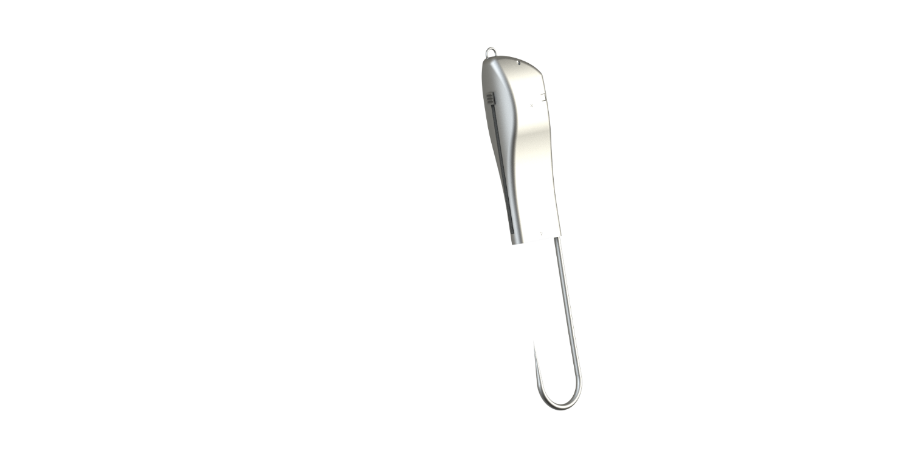

By

**Steve Buttacavoli**

**Eugene Flotteron**

**Benjamin Hall**

**Nathan Robinson**

**Bernardo Valente**

**Instructor : Kevin Russell**

**ME 408-103 – MECHANICAL SYSTEMS DESIGN II**

**SPRING 2017**



Abstract

This report contains analysis and synthesis of a mechanically activated fishing hook. The part must meet all required specifications as well as satisfying failure criteria and analysis. A spring will be synthesized based on the given dimensions of the mechanical housing and requirements to puncture through fish scale and skin. Kinematic and dynamic analyses will be performed and proven with SolidWorks Finite Element Analysis simulations. Individual parts will be analyzed and put through stress and displacement analysis. The Finite Element Analysis results will lead to appropriate material selection for each part to ensure stability and longevity of the product. Optimization of the mechanism and the parts themselves will be performed and manufacturability will be incorporated into the design, including the reduction of excess materials to reduce weight and overall material costs. A design down-select will be performed to select the most optimal and cost effective design solution that will solve the proposed objectives.

# Table of Contents

Table of Contents ii

1. Introduction 1

1.1 Problem Description and Background 1

1.2 Past Solutions to Problem 1

1.3 Existing Patents 2

US 842594 A - Fish-Hook 3

US20140283433 A1 - Spring-Loaded Fish Hook 4

US 7353633 B1 - Spring Augmented Fishhook 5

1.4 Proposed Solution 6

2. Design Analysis 10

2.1 Supporting Research 10

Line Strength 10

Fish Scale Resiliency 11

Ease of Operation 18

2.2 Formulaic Analyses 19

Spring Synthesis 19

Connecting Rod and Trigger Resistance 23

Centrifugal Force 24

Impact Force 27

Pin Shearing 29

Connecting Rod Shearing 31

2.3 Finite Element Analyses 33

The Base 33

The Hook 38

The Connecting Rod 40

The Sheath 45

The Fulcrum Pivot 50

The Pin 52

3. Design Solution and Performance 55

3.1 Solution Description 55

The Hook 55

The Connecting Rod 56

The Sheath 57

The Safety 58

The Housing 59

The Assembly 61

3.2 Solution Performance 63

4. Discussion 65

5. Conclusion 71

6. References 72

7. Appendix 1

A.1 Nomenclature 1

A.2 Project Schedule 3

A.3 Preceding Patent Claims Lists 4

US 842594 A - Fish-Hook 4

US20140283433 A1 - Spring-Loaded Fish Hook 4

US 7353633 B1 - Spring Augmented Fishhook 5

# Introduction

## 1.1 Problem Description and Background

One of the most well-known risks of fishing is having the fishing hook impaled through your own skin. The traditional barbed hook can be seen as a painful struggle when retrieving it from both your own skin as well as from a successfully caught fish. Given the situation that the barb can often perforate the insides of a fish, leading to higher mortality rates in fish due to its damage caused during removal. Figure (1-1) illustrates the how flesh can get caught behind the barb making it difficult to extract.

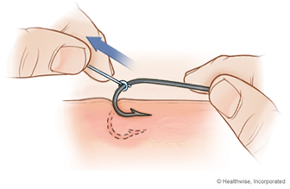

Figure ‑: Barb Stuck in Flesh

## 1.2 Past Solutions to Problem

Fishing hooks are not a new technology; the earliest fishing hook dates back to 23,000 years ago and found in the caves of Japan’s island of Okinawa. This fishing hook was made from sea snail shells, shaped as a simple crescent moon which slimmed out to a single point. [1-1] During the 17th century Europeans treated hook making as a skill left to specialists who began to use quality steels for their composition of hooks.[1-1] The earliest patent for a mechanical fishing hook was applied in 1884 and used two opposing hooks which would spring open.[1-2]

There are various designs of mechanical fishing hooks that operate with multiple hooks and spring traps, as well as fishing cages and nets that serve as different methods of catching fish and other marine wildlife. Some of these patents are referenced in section 1.3. These designs exist to fit the needs of fisherman from deep sea waters to shallow freshwater streams and rivers. A spring system is used in other fishing traps, similar to mouse traps with two hooks, but this invention is distinguished from the others by only needing one hook and therefore being less harmful for the fish being caught.

## 1.3 Existing Patents

When examining the design concept, an initial intellectual property assessment must be conducted to determine the feasibility of progressing forward with the design based on existing patents. Considering the extremely long history of fish hooks, having been in use since for over 40,000 years, the ability to patent fish hook designs relies on being able to improve upon the classic fish hook design. One of the earliest patents on fish hooks is shown in Figure (1-2):

### US 842594 A - Fish-Hook

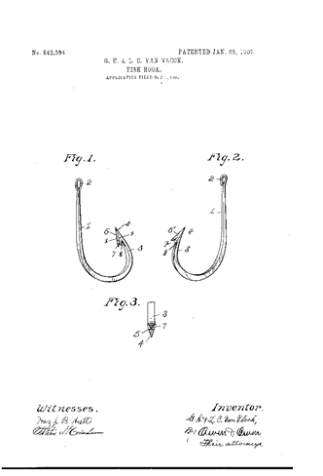

Figure ‑: Patent of Fish Hook Design Concept

Invented and owned by George H. Van Vleck, Louis C. Van Vleck, the patent shown in Figure (1-2) was filed on October 1, 1908, and expired on October 1, 1925. The key distinguishing feature of this patent was that the patent incorporated a triangular profile and forked, barbed end to ensure entrapment of the caught fish.

Designs such as the Vleck design are inherently inhumane to the fish and offer little benefit to the fisherman. The barbed end greatly increases damage to the fish upon removal of the hook and increases the likelihood of significant injury in the event of accidental ensnarement.

### US20140283433 A1 - Spring-Loaded Fish Hook

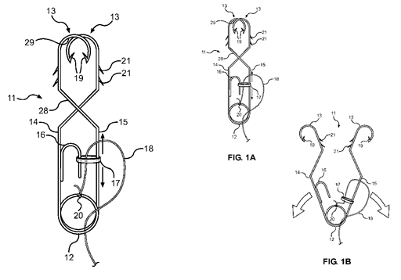

Figure ‑: Patent of Spring-Loaded Fish Hook Concepts

Invented and owned by Robert Gafford, filed on March 20, 2014, and expires on March 20, 2034, the patent shown in figure (1-3) is based around a similar idea as the proposed mechanical fish hook, where a method exists in both fish hooks that allow the hooks to hold the fish better than standard fish hooks. [1-3]

However, the claims in the patent above differ greatly from the proposed mechanical fish hook. The most fundamental difference being that the proposed concept is based around a single hook with no barb, whereas the fish hook design in the patent above is based on two hooks with barbs. The trigger mechanism is another point to examine in the patent. The manner through which the hook in the patent triggers differs greatly from the proposed method in the mechanical fishing hook concept.

### US 7353633 B1 - Spring Augmented Fishhook

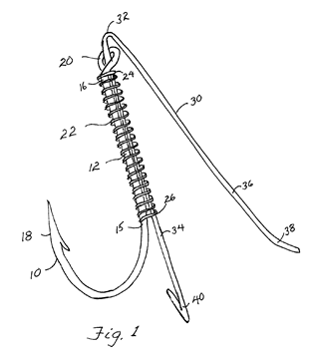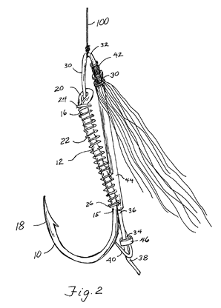

Figure ‑: Spring Augmented Fish Hook Concepts

Shown in Figure (1-4), invented and owned by Nathan C Lane, filed on October 27, 2005 and expires on October 27, 2025, the patent above is a fish hook that uses a spring in combination with a single hook and a clip. The spring used in the design prevents the hook from dislodging from the fish but the manner through which this is accomplished differs greatly from the mechanical fish hook design concept.[1-4]

The patent above has a similar idea in using a spring method to prevent a fish from getting off the hook but the manner through which it is accomplished is different. Overall, the claims of the above patents would not interfere with the mechanical fish hook design as the claims specify parts and layouts that the mechanical fish hook does not have. The full claims lists of all patents referenced here are available in Appendix A.3.

## 1.4 Proposed Solution

The mechanically activated fishing hook design has a higher probability of catching the fish than a regular fishing hook. It catches the fish with less force than the required pulling load necessary for an ordinary hook impaling through the skin of the fish. This product can be marketed to casual and committed fisherman alike, as it also has the purpose of keeping the injuries to the fish at a minimum.

The objective of the mechanically activated fishing hook and lure is to increase a fisherman’s hook up ratio, as well improving the safety and ease of removing a hook from a fish. Hook up ratio is defined to be the ratio of fish hooked to fish captured. Since fish can distinguish a lure from a real fish in less than a second a mechanism must be developed that would decrease the opportunity of the fish to make that identification. This is achieved by having a spring loaded sheath that slides over the end of a barbless hook. A barbless hook is chosen for its ease of removal from both fish and human skin. The user can easily slide the sheath back into the loaded position by moving the thumb slide on the side of the lure upwards. By making use of a locking pawl the sheath stays hidden within the body of the lure until a force is applied downward onto the hook, releasing the spring. The functioning mechanism of the fishing hook is illustrated in Figure (1-5)

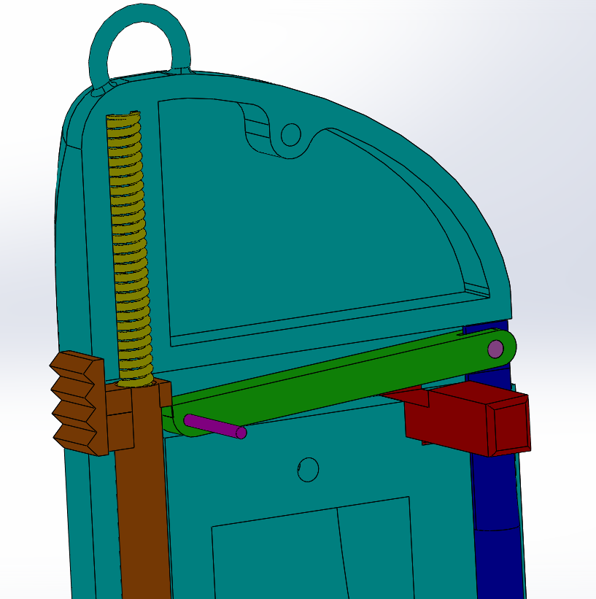

Figure ‑: Detail of Functional Mechanism of Proposed Solution

One of the most significant factors that will increase the catch rate is that the force required to activate the trap is less than the force required for a normal fishing hook to impale the skin of a fish, but more than a gentle pull. The design operates by means of a compression spring and releases this spring with the force of the fish snared on the hook.

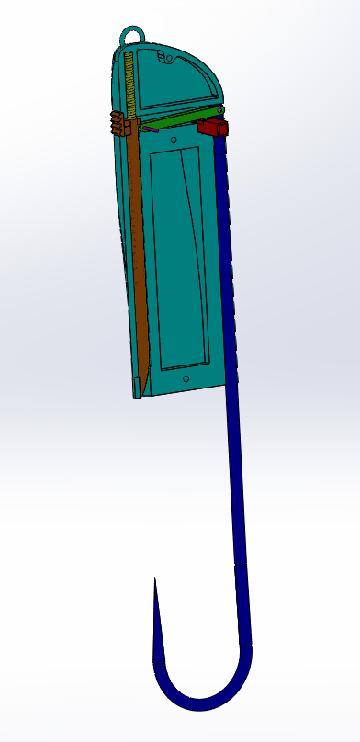

Figure ‑: Expanded View of Hook Mechanism Showing Hook and Sheath

The barbless hook can be seen both as a facilitation of the removal from the captured flesh as well as a means to minimize the damage done to the fish. This however creates the issue of live bait being able to wiggle itself out of the hook thus the type of bait needed for this specific design is either dead or artificial bait.

Releasing the successfully captured fish will be highly facilitated compared to a regular hook. After retrieving the fish from the water the user will be able to pull back on the side lever in order to retract the sheath thus opening the enclosed loop around the captured flesh. A safety mechanism has been implanted into the lure in order to prevent the sleeve from releasing when trying to remove the hook from the captured fish. These features are illustrated in Figure (1-6).

# Design Analysis

## 2.1 Supporting Research

### Line Strength

The largest smallmouth bass ever caught was recorded to weigh in at 11 pounds 15 ounces [2-1]. While researching recommended line weights for smallmouth bass, anglers recommended 8-pound test line for most fish. However, it is mentioned that because this is a thinner line, the likelihood of the line breaking is higher. Lighter lines also have a tendency stretch more easily. To reduce the likelihood of line snapping and to reduce stretch, 10-pound or 12-pound fishing line is suggested [2-2] To prevent failure in the fishing line, the highest recommended line strength was selected, which was the 12-pound line.

A study on tensile strength of various line strengths was completed by students at Santa Rosa Junior College in Santa Rosa, California. In the study it was found that 12-pound fishing line had a maximum break point of 13.3 pounds [2-3]. Figure (2-1) below shows the stress vs strain graph on a 12-pound fishing line conducted. The maximum load that can be held on the hook is therefore 13.3 pounds. A 13.3 pound force can be converted to 59.1614 N. For the force studies on the lure a 60 Newton force was chosen to be applied to the hook. The line will fail before the any mechanical part of the fishing hook, which ensures the integrity of the product.

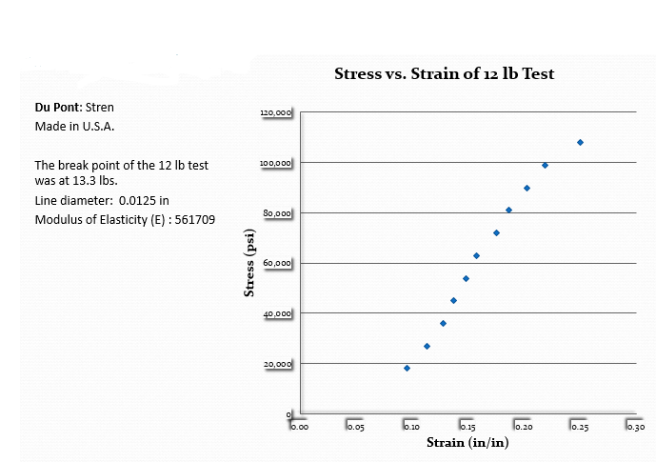

Figure ‑: Stress Strain Diagram of 12 lb Test Line

### Fish Scale Resiliency

The majority of the body of a fish is covered by scales. Figure (2-2**)** (a) shows the scalation pattern. The pattern for the scales of a striped bass are arranged in layered rows across the length of the fish. It has been found that each scale overlaps with six other neighboring scales. This can be seen in Figure (2-2) (b), where three scales are located on the anterior side, and then three scales on the posterior side. The scale arrangement of the fish attributes to an overlapping coverage of three scales at any point on the surface of the fish. The absolute size of individual scales will vary in dimension with the age of the fish; this is because a fish will keep growing indefinitely as it ages. The scales are, however, not uniform in size over the entire fish. The scales are the smallest near the tail and near the head. [2-4]

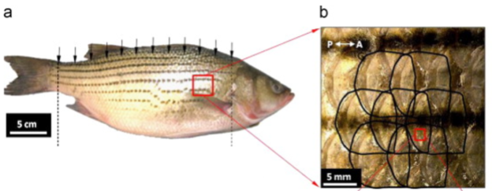

Figure ‑: Fish Scale Arrangement and Overlapping

A test was conducted on half of a striped bass to determine the puncture performance of fish skin. The fish was placed in immersed condition and a sharp needle with a tip radius of 35 µm was mounted on a universal testing machine and the needle was driven through the skin of the fish. The test was performed on fully scaled fish and then again on an entirely descaled fish for comparison. The test results show proof that the scales form an effective barrier, and because of this, increased the puncture resistance of the skin by four to five times, shown in Figure (2-3), below. It can be shown that it takes roughly 14 Newtons maximum to penetrate the fish with scales. Without scales, the max force required to penetrate would be about 4 Newtons. [2-5]

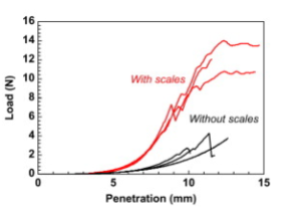

Figure ‑: Penetration Force Required for Fish Skin and Scales

Similarly, a sharp steel needle test with a needle tip radius 25 µm was used by Zhu. The needle was driven through a scale resting on a silicone rubber substrate used to simulate the soft dermis and tissues underlying the scale, at a speed of 0.005 mm*s-1 while the force was recorded. Figure (2-4), below, shows the load-deflection curves that were generated from the tests.

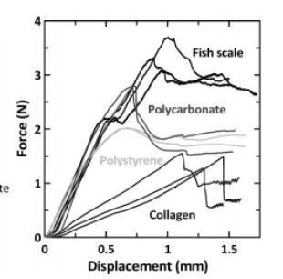

Figure ‑: Force and Displacement Diagram of Fish Scale

For comparison, puncture tests were performed on thin polystyrene and polycarbonate, which are common engineering polymers. Figure (2-5), below, shows the detailed sequence of a puncture test through fish scales with “bony layer” removed. [2-4] Similar to the above study, Figure (2-5) shows evidence that the fish scales provides much more resistance than fish skin, and requires a max force of about 3.7 Newtons. [2-5]

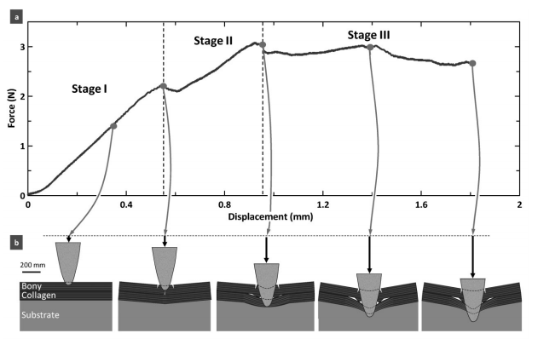

Figure ‑: Penetration of Testing Needle through Fish Scale and Substrate

The tests mentioned above were performed through the center of the scales of the fish. It was thought that the puncture performance probably depends on the puncture location, because the farther away from the center of the scale, the thinner the scale becomes.[2-4] To find the effect of the puncture site, scientists then performed puncture tests on a single fish scale at five different locations on the upper surface of the scale, which can be seen in Figure (2-6). The puncture force-displacement curves at each puncture site showed very similar patterns. The performance of the scale in resisting puncture was shown to be site dependent, for a single fish scale, as originally theorized. However, when testing the “effective” thickness of the scale by superposing three scales as found on the fish naturally, the thickness is uniform over the surface of the fish. This presented data that the puncture resistance on fish scales as found naturally on a fish were less dependent on location than for the individual scale. [2-5]

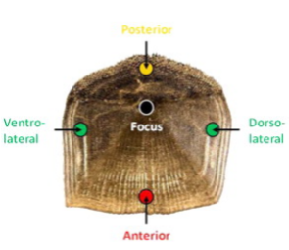

Figure ‑: Penetration Testing Sites on an Individual Fish Scale

The same experimental setup that was used for the single scale test was used to test multiple scales, since it is implied that more scales will effect that amount of force it takes to pierce completely.

Scales were stacked into piles as in Figure (2-7). The scales overlapped one another with the same orientation. A central location of the scale was targeted for puncture and the needle driven through the entire stack of scales. The force–displacement curves for stacks of the scales are shown in Figure (2-8). The force required to puncture the stack of scales increased with the number of scales. Similar failure was observed with the stacked scales as for single scales. [2-5]

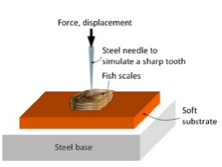

Figure ‑: Penetration Testing on a Stack of Scales

Puncture force increases almost linearly with the number of scales, at least up until 3 scales, which can be observed in Figure (2-8). Since striped bass have three overlapping scales cover the fish at any point, this number was conveniently used for the fish hook analysis. The maximum force that was exerted on 3 fish scales was around 12 Newtons.[2-5] Design studies were therefore based of a required force of 15 Newtons, to allow for a factor of safety.

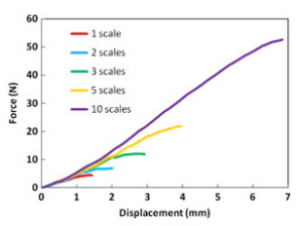 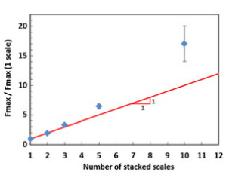

Figure ‑: Force Required for Penetration Relative to Number of Scales

Friction between scales was thought to increase puncture resistance. A study was conducted to determine the coefficient of friction between the scales. In the study the interface between the substrate and the scale was assumed to be frictionless, since both surfaces are smooth and hydrated. The properties of the bony and collagen layers within the scales were taken from previous experiments on striped bass scales. [2-5]

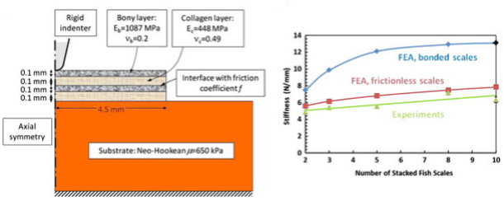

Figure ‑: Indentation and Stiffness Relative to Number of Scales

In order to investigate the effect of friction between scales, finite element models were generated with stacks of scales as seen in Figure (2-9). The unknown parameter in the model was the friction between the scales. Extreme cases were considered for study. One being perfectly bonded scales and the second case being frictionless scales.

Figure (2-9) shows the study of initial predicted slopes of stiffness and the experimental slope, as predicted and tested in study by Deju Zhu, Lawrence Szewciw, Franck Vernerey, and Francois Barthelat as function of number of scales. The initial stiffness is seen to be increased with number of scales, and stacks of bonded scales are stiffer than frictionless scales. The model did not take the thickness of the scale into account and the scale was assumed to be uniform throughout. However, the model suggests that the friction between the scales is negligible, since the frictionless models were the closest to the experimental results. [2-5]

In conclusion, fish have a scale pattern that attribute to three layers of scales to resist puncture at any point on the fish’s surface, which effectively shows that puncture force is multiplied by three. There are significant variations in thickness within an individual scale, but the pattern of the scales are such that the total “effective” protective thickness is uniform over the entire fish. The local arrangement of the scales was also found to have little effect on the puncture performance. Friction between scales was also determined negligible, and therefore does not generate additional resistance to puncture, regardless of scale arrangement.

### Ease of Operation

For the user to be able to operate the product, it is necessary to limit the maximum force needed to be applied by the user onto the side trigger in order to load the spring. This force should be less than the average force of a human thumb. To determine this limiting force, Alfred B. Swanson’s orthopedic research study, *The Strength of the Hand* was referenced. [2-6] This study surveyed the grip and pinch strength of 100 individuals. Tests were made before hand in order to determine the average individuals preferred pinch method and then continued on to test their strength with an electronic pinch meter designed with strain gages.

With the results displayed by occupation (skilled, sedentary and manual) for both male and female pinches with their major and minor hands, the weakest tested strength was chosen as the limiting factor for the maximum force needed to load the spring. The sedentary female minor hands held the weakest chuck pinch recording 4.0 kg-force, converting this into Newtons gives a force of 39.24 N thus the design of the spring is constrained to a maximum of this force.

Table : Average Strength of Grip by Occupation [2-6]

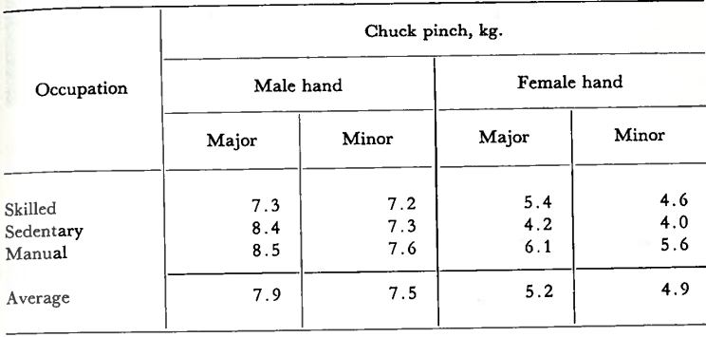

Additionally, a safety mechanism was designed for the purpose keeping the user’s hands and fingers safe when placing the bait on the hook and when removing the captured fish from the hook. By having the safety catch at a safe distance from sharpest parts of the design (the hook and sheath) the user can confidently retract the sheath and slide the safety catch to prevent the operation of the mechanism.

## 2.2 Formulaic Analyses

### Spring Synthesis

In order to calculate the resulting force needed to penetrate through fish skin for our spring loaded 14 Gauge Sheath, we used the studies found from Deju Zhu’s, Structure and Mechanical Performance of a “Modern” Fish Scale. As stated in Section 2.1, Zhu uses a needle with a tip diameter of 50 µm (radius of 25 µm). It was found that with a radius of 25 µm a force of about 12 Newtons was needed to puncture 3 fish scales.

The pressure equation, Equation (2-1) was then used to figure out how much force was required to drive the spring loaded sheath to penetrate all fish layers.

$P=F/A$ (2-1)

Where: $$P=Pressure, Pa \\ F=Force, N \\ A=Surface area of needle tip, m^{2}$$

Given: $$r=25μm=2.5x{10}^{-5}m \\ F=15N$$

And,

$$A=πr^{2}= π{\left(2.5x{10}^{-5}m\right)}^{2}=1.963x{10}^{-9}m^{2}$$

Substituting into Equation (2-1):

$$P=\frac{15N}{1.963x{10}^{-9}m^{2}}=7.64x{10}^{9}Pa$$

To calculate the force required for the 14 gauge sheath, the value of the pressure and surface area of the sheath tip,

$$r=35μm \\ A=πr^{2}=π{\left(3.5x{10}^{-5}m\right)}^{2}=3.8485x{10}^{-9}m \\ F=PA=\left(7.64x{10}^{9}Pa\right)\left(3.8485x{10}^{-9}m^{2}\right)=29.4N$$

29.4 Newtons is therefore the force required to puncture the sheath of the mechanical fishing hook through a fish.

Hooke’s Law, shown in Equation (2-2), can be used to find the spring constant k. [2-7]

$ΔF=kΔx$ (2-2)

Where: $$F=force, N \\ k=spring constant,\frac{N}{m} \\ x=distance, m$$

From the research and design constraints: $$F_{1}=Force of Penetration=29.4N \\ F_{2}=Force of Hand Strength=39.24N \\ Δx=length of closure=0.04155 m$$

Therefore, from Equation (2-2):

$$k=\frac{F_{2}-F_{1}}{Δx}=\frac{39.2N-29.4N}{0.04155m}=240.96\frac{N}{m}$$

Hooke’s law is then used to calculate the total length of deflection of the spring based on the spring constant and the required force at full compression. From equation (2-2):

$$Δx_{total}=\frac{F}{k}=\frac{40N}{240.96\frac{N}{m}}=166.00mm$$

The free length of the spring is calculated according to equation (2-3), where xcompressed is the maximum length of the fully compressed spring based on design constraints:

$x_{free}=Δx_{total}+x_{compressed}$ (2-3)

$x_{free}=166 mm+40 mm=206 mm$

Finally, the diameter of the wire needed to form the spring could be found using our calculated results and our decided dimensions for the spring housing. This was done using two equations, Equations (2-4) and (2-5). [2-7]

$k=\frac{d^{4}G}{8D^{3}N}$ (2-4)

$x_{compressed}=d*N$ (2-5)

Where: $$d=diameter of wire, m \\ D=diameter of coil, m \\ G=shear modulus of elasticity, Pa \\ N=number of turns of the coil$$

Substituting Equation (2-5) into Equation (2-4) and rearranging, Equation (2-6) is identified to calculate the wire diameter:

$d={\left(\frac{8k\left(x_{compressed}\right)\left(D^{3}\right)}{G}\right)}^{\frac{1}{5}}$ (2-6)

The shear modulus for spring steel is 77 GPa.[2-8] Based upon design constraints, the maximum value for D is .0015m. Using these values and those calculated earlier:

$$d={\left(\frac{8\left(240.96N/m\right)\left(.040m\right){\left(.0015 m\right)}^{3}}{77x{10}^{9}Pa}\right)}^{\frac{1}{5}}=3.204x{10}^{-4} m=.320 mm$$

### Connecting Rod and Trigger Resistance

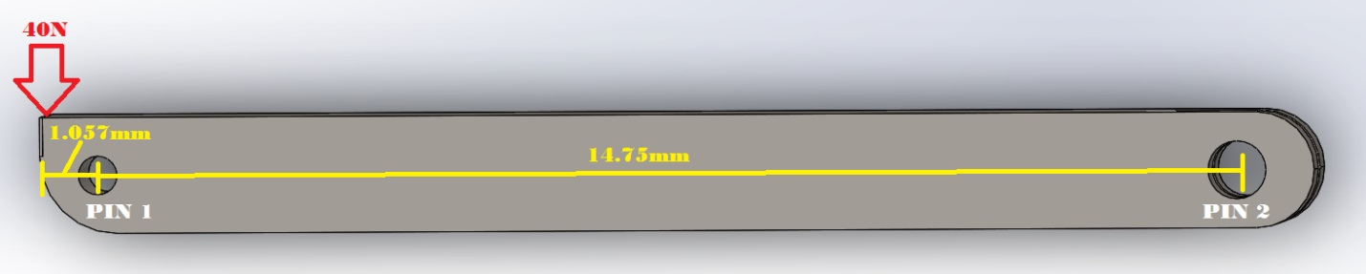

Figure ‑: Connecting Rod and Dimensions

The connecting rod which activates the sheath through movement in the hook uses two pins as seen in Figure (2-10), above. The first pin, pin 1, closest to the sheath will act as a fulcrum point allowing for the connecting beam to rotate. The pin located above the hook, pin2, allows for the hook to apply the needed moment to move the bar out of the way when the hook is pulled down. Since the spring powering the sheath has a force of 40N it was vital to determine the reactionary force needed from the hook to trigger the system. By using a sum of moments around the fulcrum pin, shown in equation (2-7), the reaction force needed to pull the hook down to trigger the system is calculated.

$\sum{M_{PIN1}}=F_{spring}\left(∆x\right)-F_{PIN2}\left(∆x\right)=0$ (2-7)

$40N\left(1.057mm\right)=F_{PIN2}\left(14.75\right)$

$F_{PIN2}=2.86N$

Where:

$$\sum{M_{PIN1}}= The summation of moments around pin 1. \\ F_{spring}=Force of spring (40N) \\ ∆x= Perpendicular distance from force to pin 1. \\ F_{PIN2}= force acting on pin 2$$

Since the reaction force of pin 2 is 2.86N any force above that will cause the mechanism to release the sheath.

### Centrifugal Force

Considering that the centrifugal force of casting the lure would falsely trigger the system an ultimate situation was developed to check for unintentional triggering. Research was conducted to find the longest recorded casting distance in competitive fishing.[2-9] This value was 88.4 meters. The optimal form and release point when casting for distance is to rotate the rod through the angle of 30-150 degrees relative to the horizontal.[2-9] From here, simple kinematics equations in two dimensions, equations (2-8) and (2-9), are applied that would be substituted into each other to find the final velocity at the point of release.

For y-axis $∆y=V_{0_{y}}t+\frac{1}{2}at^{2}$ (2-8)

$$0=V_{0}sin⁡(30)t+\frac{1}{2}(-9.8)t^{2}$$

For x-axis $∆x=V_{0_{x}}t$ (2-9)

$$88.4m=V_{0}\cos\left(30\right)t$$

Where:

$$∆y= height along y-axis \\ Δx=distance along x-axis \\ V_{0}= Release velocity \\ t= time \\ a= acceleration, which for y axis is 9.8\frac{m}{s^{2}}$$

Algebraically: $t=\frac{88.4}{V_{0}\cos\left(30\right)t}$

This is then substituted into y-axis equation:

$$0=\frac{V_{0}\sin\left(30\right)}{V_{0}\cos\left(30\right)}\left(88.4m\right)+\frac{1}{2}\left(9.8\right){\left(\frac{88.4}{V_{0}\cos\left(30\right)}\right)}^{2} \\ 88.4\tan\left(30\right)=4.905{\left(\frac{88.4}{\cos\left(30\right)}\right)}^{2}{V_{0}}^{-2} \\ {V_{0}}^{2}=\frac{4.905}{88.4tan⁡(30)}({\frac{88.4}{cos⁡(30)})}^{2}$$

From these calculations, linear velocity was calculated to be 31.644 meters per second. This could now be used to find the angular velocity of the casting throw. It has been determined that an optimal casting angle is 120 degrees, shown in Figure (2-11) and that it only takes 0.5 seconds to cover that angle.[2-9] The angular velocity, equation (2-10), can then be used to calculate the centrifugal force, equation (2-11), on the mass of the hook and lure using a rod length of 7ft or 2.133 meters. The mass of the hook and a heavy bloodworm was 0.04259kg.[2-10]

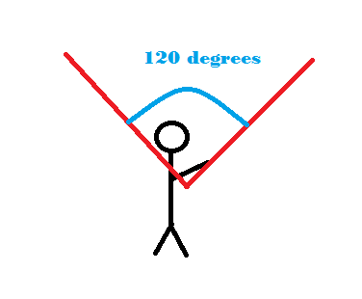

Figure ‑: Angle of Travel of a Casting Motion

Angular velocity:

$ω=\frac{θ}{t}=\frac{120}{0.5}=240(\frac{rad}{sec})$ (2-10)

Centrifugal Force:

$F=Mω^{2}r$ (2-11)

$$F=\left(0.04259\right){\left(4.188\right)}^{2}\left(2.13m\right)=1.593N$$

Where:

$$ω= Angular velocity \\ θ= Angle of cast throw \\ F= Centrifugal force \\ r= Radius of cast throw (length of rod.)$$

The accelerating force acting on the hook and lure due to casting is 1.593N. Being that the force needed to activate the system is 2.86N, our system is safe in terms of acceleration force.

### Impact Force

In order to conduct the Finite Element Analysis on the sheath, as the sheath approaches full extension, the analysis required the force of impact at which the sheath hits the restraint (the hook housing). Knowing the properties of the spring, the mass of the sheath, the distances of travel, and time required to stop the momentum of the sheath; the following can be calculated using kinematic equations,

Given:

$$m_{sheath}=0.00059 kg \\ K= 241\frac{N}{m} \\ Δx_{total}=0.166 m \\ Δt=.001 sec \\ Δx_{travel}=.0475 m \\ V_{o}=0 m/s$$

$$a=\frac{k}{m_{sheath}}Δx=\frac{241\frac{N}{m}\left(0.166 m\right)}{0.00059 kg}=67,806.78 m/s^{2} \\ V_{f}^{2}=V_{o}^{2}+2aΔx=0+2\left(67,806.78\frac{m}{s^{2}}\right)\left(0.0475 m\right) \\ V_{f}=80.26 m/s \\ F_{impact}=\frac{m_{sheath}ΔV}{Δt}=\frac{\left(0.00059 kg\right)\left(80.26\frac{m}{s}\right)}{0.001 sec}=47.35 N$$

The resultant force as the sheath makes contact with the housing is therefore about 48 N.

### Pin Shearing

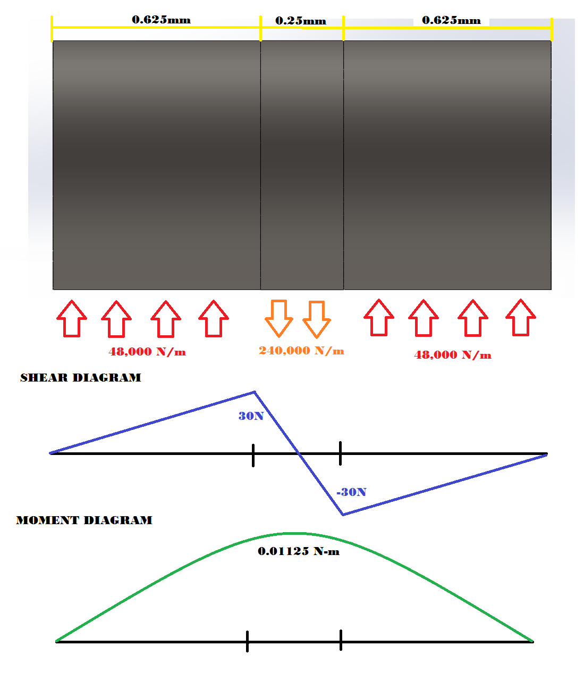

Figure ‑: Force Shear and Moment Diagram for Pin Connection

When considering analysis of the pin it is essential to find the shearing diagram as well as the moment diagram to fully understand the dynamics. A load of 30 N is applied directly over the center of the pin for a width of 0.25mm. For the reaction forces on either side of the pin, with width of 0.625mm, the distributed load is 48,000N/m. As seen in Figure (2-12), above, the minimum shear is at the edges and towards the center the maximum shear occurs at the intersection of the equilibrium line. That shearing force is 30N. The moment curve in Figure (2-12) above illustrates how the pin will bend and where. Since the two ends are fixed, the maximum bending moment is directly in the center of the pin at a value of 0.01125N-m

$$V=F*Δx=48,000 \frac{N}{m}*.000625 m=30 N$$

$$M= ∫Vdx=\frac{1}{2}V_{maximum}*Δx=\frac{1}{2}*30 N*\left(0.000625 m+0.000125 m\right)=0.01125 Nm$$

$$σ=\frac{Mc}{I}=.01125\frac{Nm\left(3.75x{10}^{-4} m\right)}{1.553x{10}^{-14}{ m}^{4}}=2.717x{10}^{8} Pa$$

$$τ=\frac{4}{3}\left(\frac{V}{A}\right)=\frac{4}{3}\left(\frac{30 N}{4.4186x{10}^{-7} m^{2}}\right)=9.053 MPa$$

Where:

$$M= Moment \\ F= Applied force \\ d= Perpendicular distance \\ τ= Shearing force \\ V = Force \\ b= base dimension \\ h= Height dimension \\ I= Inertia \\ σ_{B}= Bending stress \\ A=Area$$

### Connecting Rod Shearing

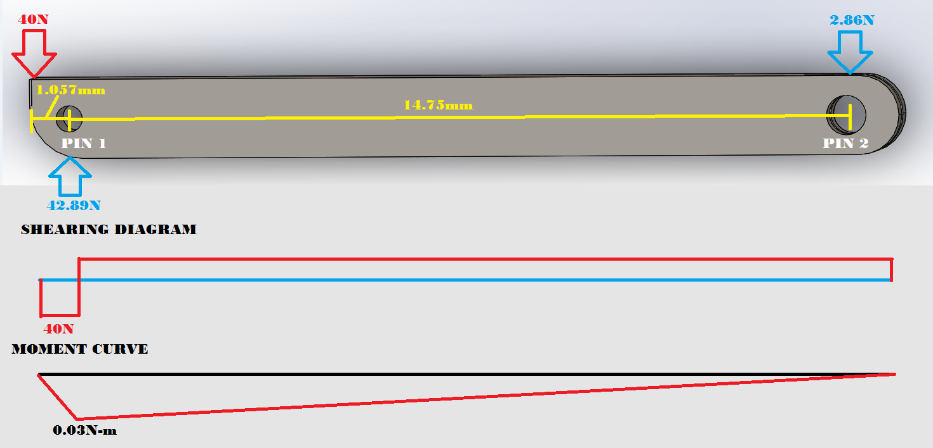

Figure ‑: Shearing Diagram and Moment Diagram for Connecting Rod

Analysis of the connecting rod entailed finding the shearing diagram as well as the moment diagram to fully understand the dynamics. A load of 40 N was applied to left most side, this is where the force from the spring rests on the rod. For the reaction forces on pin 1 and pin 2 we found these values to be 42.89N and 2.86N respectively. As seen in Figure (2-13), the maximum load applied is 40N. Towards the right the shearing curve intersects the equilibrium line where the reaction force changes direction. The moment curve also seen in Figure (2-13), illustrates how the rod will bend due to fact that the ends can pivot. The maximum moment is 0.03N-m and seen at Pin 1.

$$M=F*d=40 N*0.00075 m=.03 Nm$$

$$τ=\frac{V}{bh}$$

$$I=\frac{1}{12}bh^{3}=\frac{1}{12}\left(0.0015 m\right){\left(0.0015m\right)}^{3}=4.218x{10}^{-13} m^{4}$$

$$σ_{B}=\frac{My}{I}=\frac{\left(0.03 Nm\right)\left(0.00075 m\right)}{4.218x{10}^{-13}}=53.343x{10}^{6} Pa$$

Where:

$$M= Moment \\ F= Applied force \\ d= Perpendicular distance \\ τ= Shearing force \\ V = Force \\ b= Base dimension \\ h= Height dimension \\ I= Inertia \\ σ_{B}= Bending stress \\ y=Half width of rod$$

## 2.3 Finite Element Analyses

### The Base

The base of the mechanically operated fishing hook is a machined shell in two parts to be assembled using three body screws. The part will be in steel with a bright finish to mimic the appearance of a school fish when moving through the water. The part will be machined to include channels for the necessary mechanical components, as well as areas shelled out for weight reduction. These features are highlighted in figure (2-14).

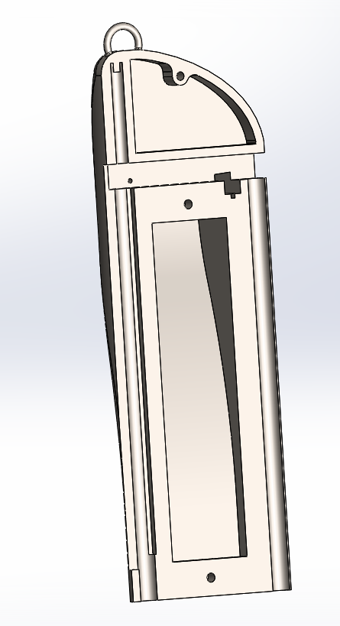

Figure ‑: Base Housing of the Mechanically Operated Fishing Hook

The base is the part of the assembled device that will be tied directly to the line. Thus, all loads applied to the assembled device will be transferred to the line by the loop at the top of the body.. The material chosen for the base is AISI 4340 normalized steel with yield strength of 710 MPa.

The displacement analysis for this part, Figure (2-15) shows a maximum displacement of 0.00557 mm. The areas that are most affected by the loads are the eye of the string attachment and the lower left end of the base. The additional loads tested on the body result from the pre-load compression of the spring.

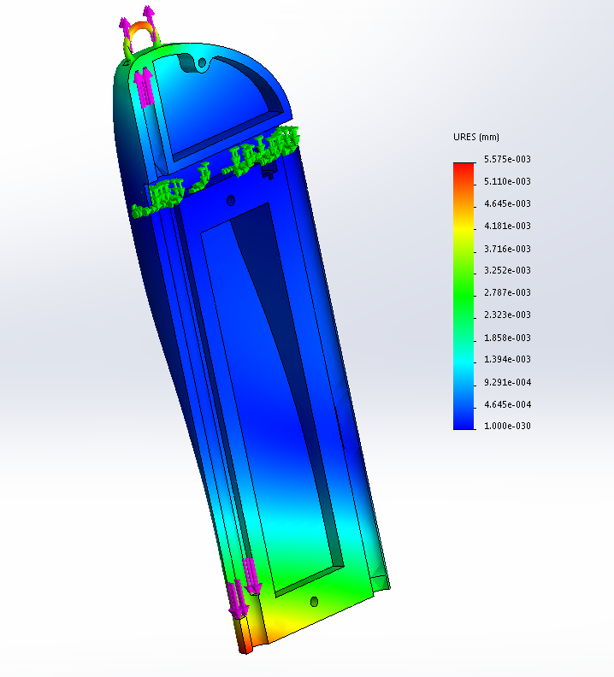

Figure ‑: Finite Element Analysis of Displacement on the Body

The Von Mises analysis of the string eye part of the body, Figure (2-16) shows a maximum stress of 237 MPa for a load of 60 N acting from the string.

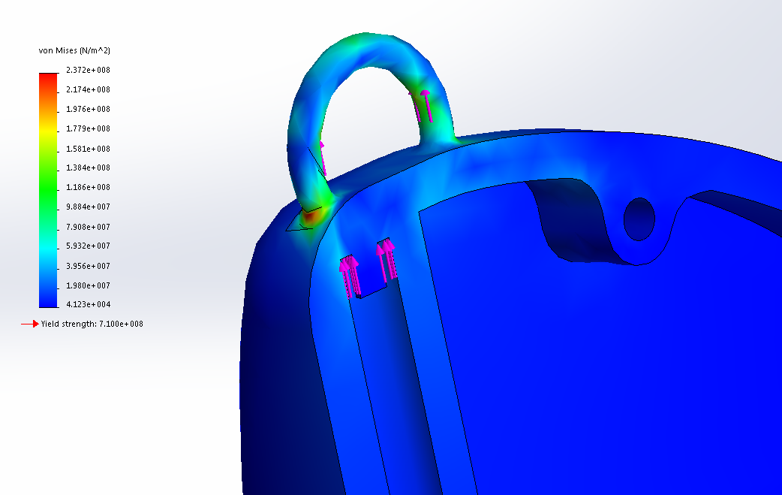

Figure ‑: Finite Element Analysis of Von Mises Stresses on the Body

Figure (2-17) shows the finite element model analyzing the stresses generated from the fully loaded compression spring on the base. The maximum stress of 74 MPa is far below the material yield strength of 710 MPa.

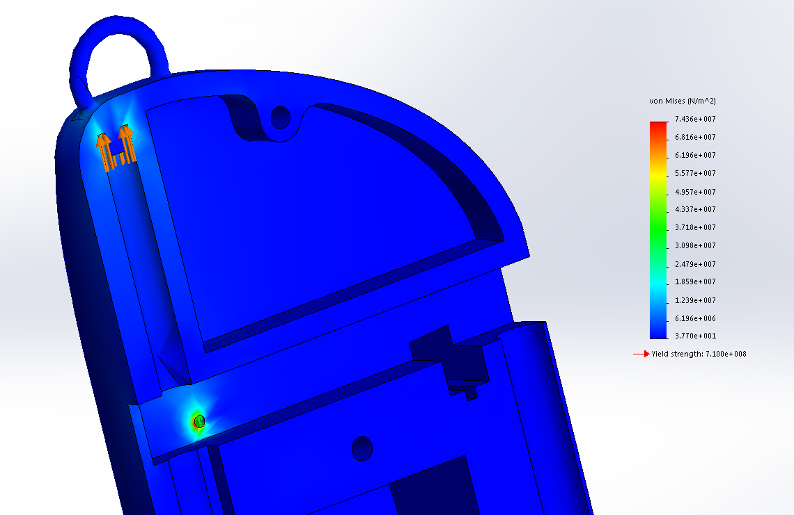

Figure ‑: Finite Element Analysis of the Body when Armed

The lower left end of the base is designed for the purpose of stopping the sheath from traveling further. The sheath impacts these stoppers with an impact force of 44 N, and the Von Mises analysis shows a max stress of 170.2 MPa, as shown in Figure (2-18).

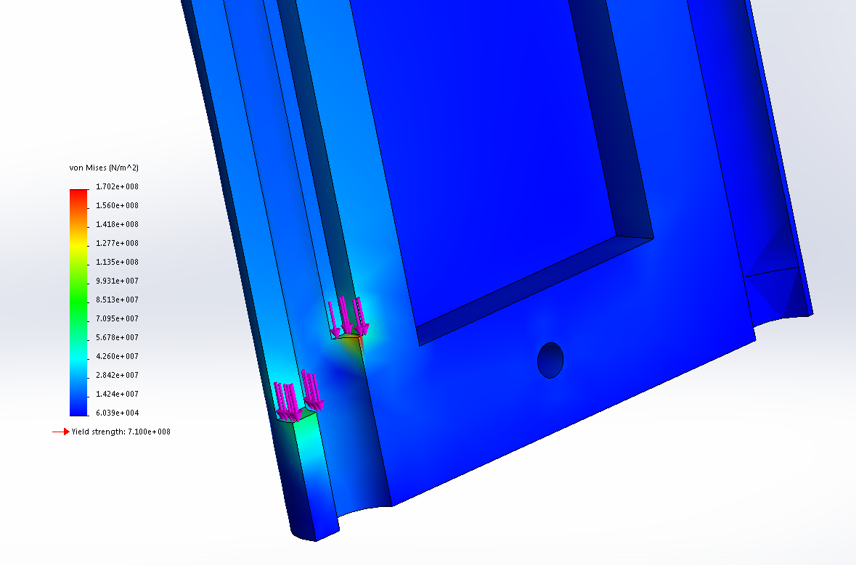

Figure ‑: Finite Element Analysis of Von Mises Stress Resulting from Sheath

### The Hook

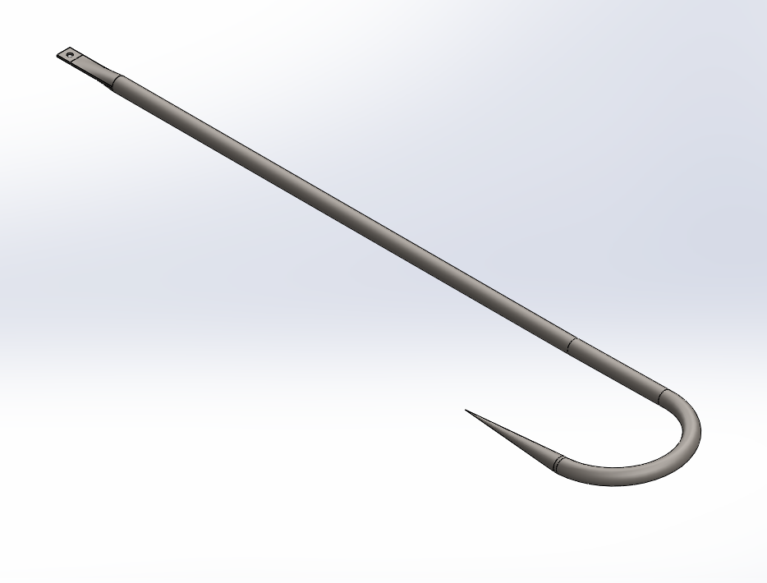

Figure ‑: Hook Design

The hook is designed to be cut from a single piece of wire, with the hook end sharpened and the connecting end formed into a closed loop, as shown in Figure (2-19). The hook will carry the force applied by the captured fish to the mechanism inside the body. The testing force to be applied on the hook is 60 N, as discussed in section 2.1. AISI 4340 normalized steel was chosen for the hook in order for it to carry the necessary load.

The finite element displacement analysis undergoing the design load of 60 N, shows the hook to have a maximum displacement of 1.499mm located at the tip, seen in Figure (2-20).

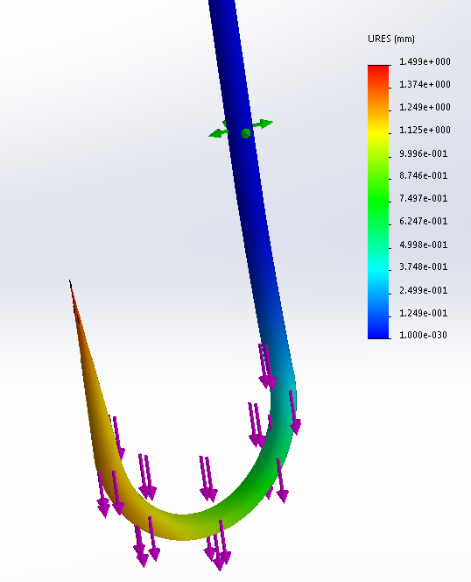

Figure ‑: Finite Element Analysis of Hook Displacement

Furthermore, a Von Mises stress analysis, Figure (2-21), allows for the representation of the area of the hook that will be undergoing the highest amount of stress resulting in a maximum stress of 699 MPa towards the inside of the hook’s shank. The yield strength of AISI 4340 normalized steel is 710 MPa, thus able to endure the target load.

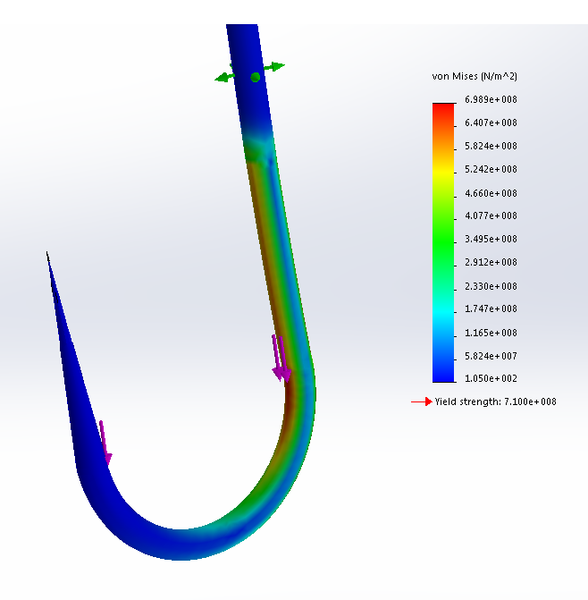

Figure ‑: Finite Element Analysis of Von Mises Stress in the Hook

### The Connecting Rod

The connecting rod acts as a trigger that holds the sheath in the set position. The connecting rod is fixed to the hook by a pin, and to the body by a pivot. The connecting rod experiences its most significant stresses at the sheath end when the mechanism is set, and at the hook end when the hook is loaded.

When the spring is loaded the connecting rod rests at an angle of 3.89 ̊. In order for the sheath to be released the connecting rod must rotate a total of 3.52 ̊, thus reaching a release angle of 0.37, as shown in Figure (2-22). ̊

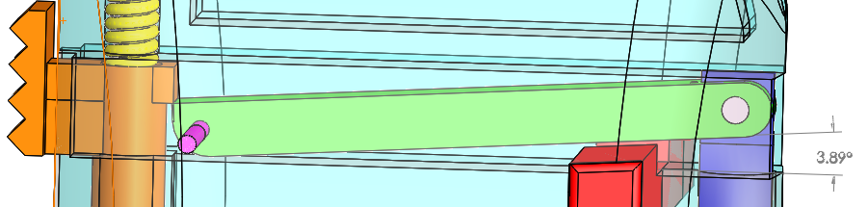  
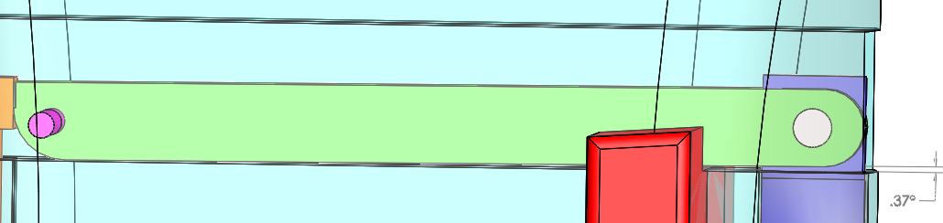

Figure ‑: Connecting Rod in Set and Triggered Positions

The finite element displacement analysis, Figure (2-23), for the edge of the rod undergoing the 40 N load generated from the contact with the sheath shows a maximum displacement of 1.129 μm.

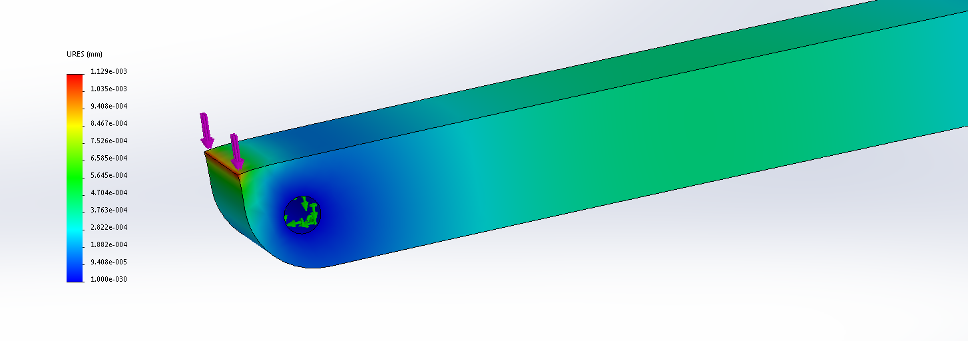

Figure ‑: Finite Element Analysis of Connecting Rod Displacement

For end of the rod attached to the hook and pin the displacement shows a maximum displacement of 0.949 μm toward the upper right side of the hole, shown in Figure (2-24).

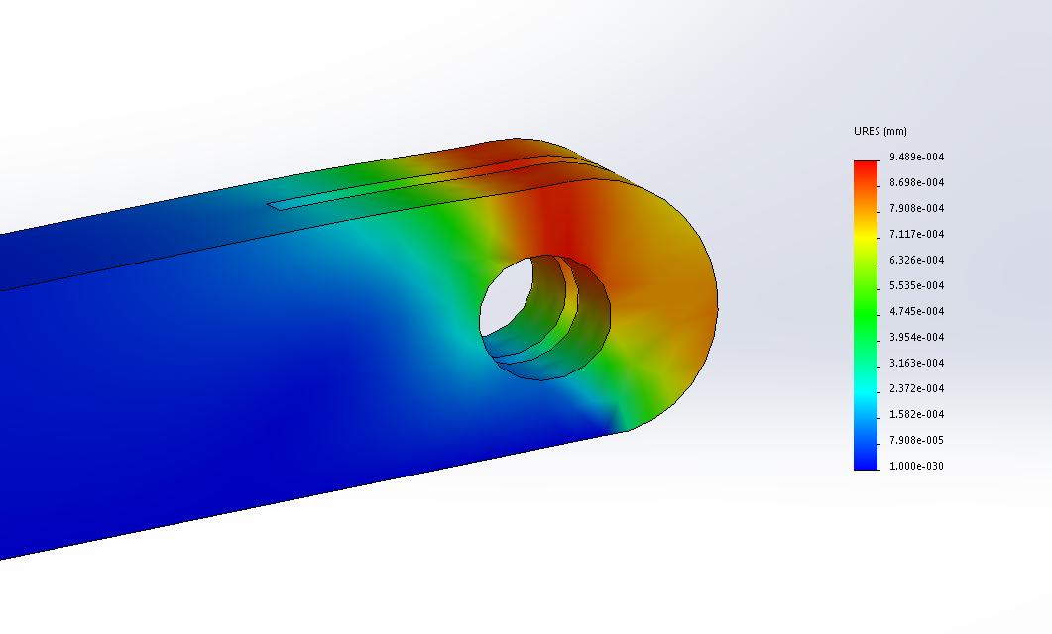

Figure ‑: Finite Element Analysis of Displacement of the Connecting Rod

The von Mises analysis, Figure (2-25), for the connecting area undergoing the 40 N load displays a maximum stress of 566MPa, which is lower than the material yield strength of 710 MPa.

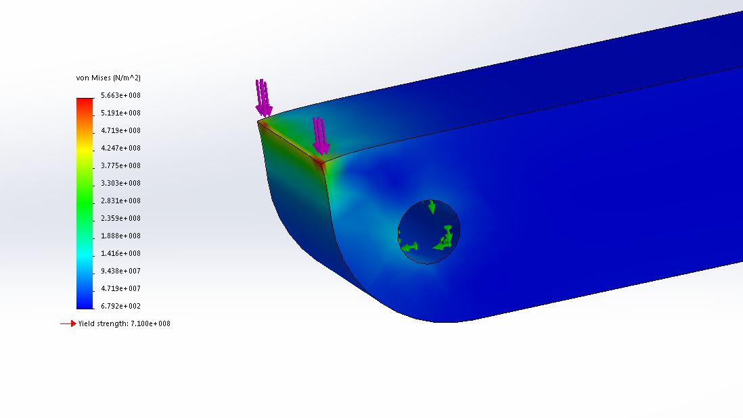

Figure ‑: Finite Element Analysis of the Connecting Rod for Von Mises Stress

Figure (2-26) below shows the Finite Element Analysis of the fatigue on the connecting rod. It was determined that the connecting rod experiences the most wear due to constant pressure and friction being applied to the tip of the connecting rod. The fatigue analysis ran for a duration of 1,000 cycles, and it was determined that the max damage that would be produced on the connecting rod was 30%.

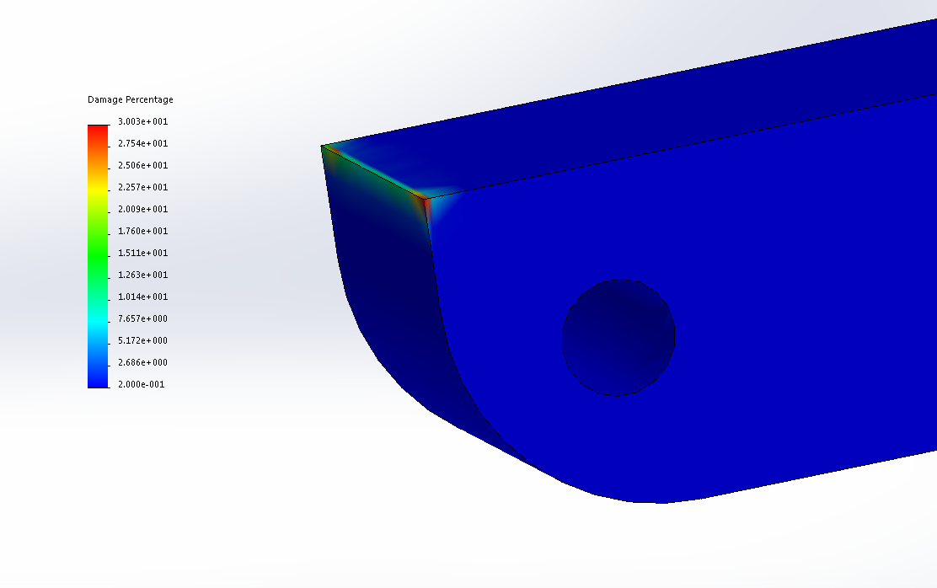

Figure 2-26: Finite Element Analysis of the Fatigue of the Connecting Rod after 1,000 Cycles

### The Sheath

This part activates to secure the captured fish within the enclosed loop as well as to aid in the perforation of the fish onto the barbless hook. When a force greater than 2.8 N is applied to the hook, the hook will pull down on the connecting rod with torque advantage making it rotate about its pinned fulcrum point allowing the release of the sleeve with a force of 39.24 N.

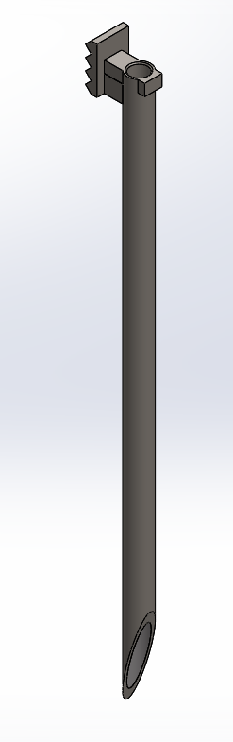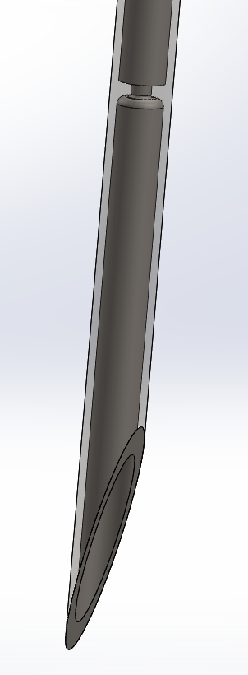

Figure ‑: Design Features of the Sheath

The tip of the sleeve, as shown in Figure (2-26) is pointed for the purpose of focusing the force onto a single point of contact. For the tip of the sleeve to perforate a three scale overlap of fish skin a minimum force of 29.4 N is needed.

There is a bump stop on the top back side of the sheath, shown in figure (2-26) in order to make contact with the connecting rod when the connecting rod is in a slanted position at 3.89 ̊. This extrusion will slide across the point of contact until the connecting rod reaches an angle of 0.37 ̊.

Two displacement analysis were done for the sheath, one for when the sheath is in the spring loaded position with a load of 40 n being applied downward on the sheath, and one for when it’s in the released position, shown in Figures (2-27) and (2-28). The maximum displacements are 3.171 μm and 9.271 μm respectively.

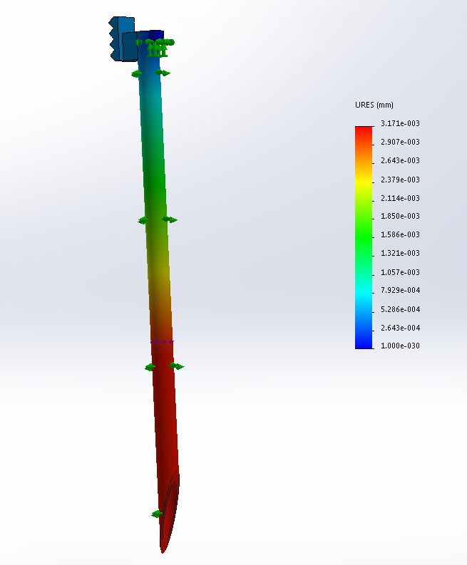

Figure ‑: Sheath Displacement Analysis, Extended

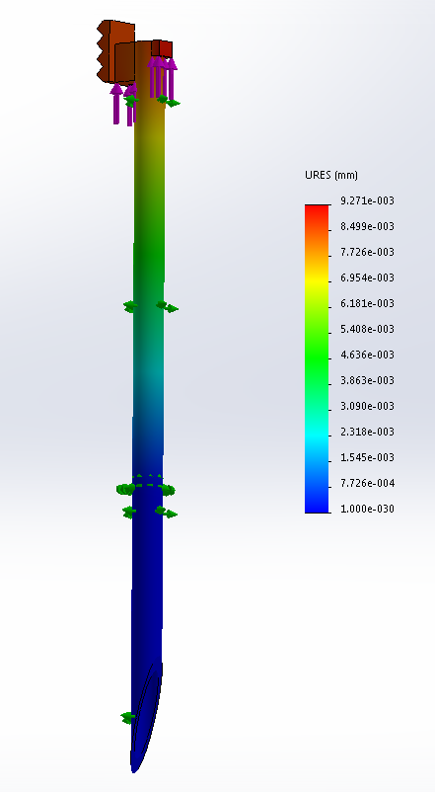

Figure ‑: Displacement Analysis of Sheath in Set Position

The finite element analyses for the Von Mises stress were conducted for both the set and released positions of the sheath, shown in Figure (2-29) and (2-30)

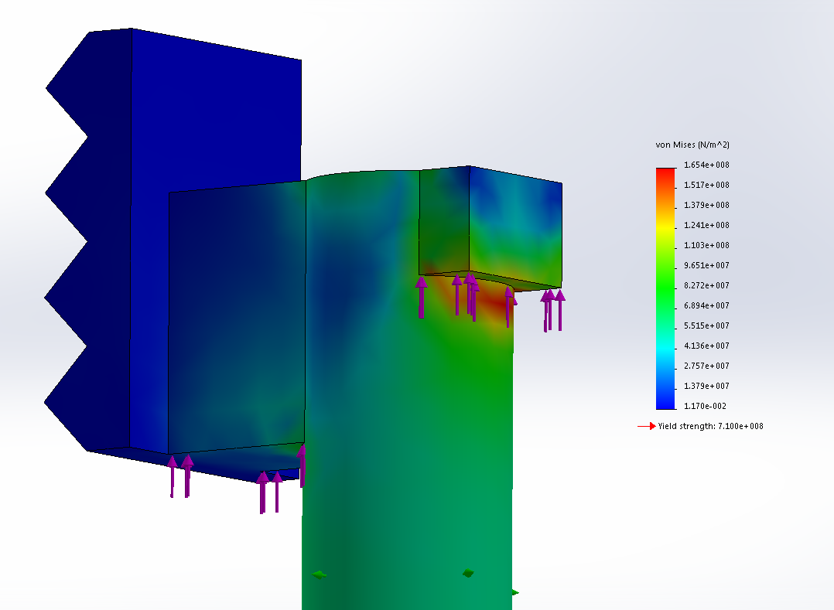

Figure ‑: Von Mises Stress in Extended Sheath

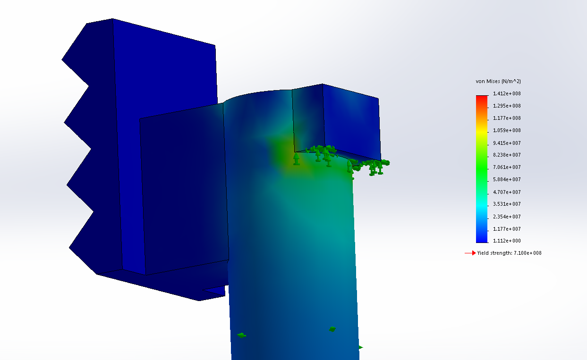

Figure ‑: Von Mises Stress Analysis for Sheath in Set Position

### The Fulcrum Pivot

The fulcrum pivot acts as a pivot for the connecting rod by fixing it to the base and case parts. The pivot is primarily subjected to shearing forces from the interfaces with the body and connecting rod. As shown in Figure (2-31), the pivot is a simple pin design.

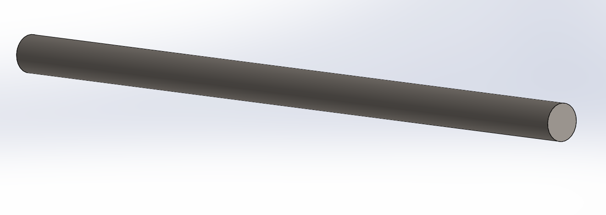

Figure ‑: Fulcrum Pivot

For the fulcrum pivot’s displacement analysis, Figure (2-32) a load of 42.8 N was applied to the area of contact displaying a max displacement of 1.37 μm.

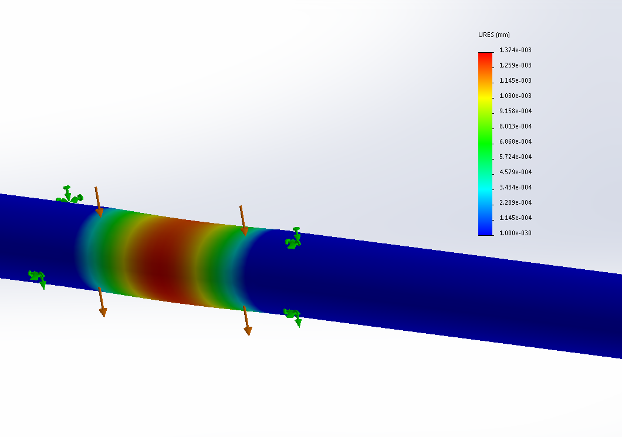

Figure ‑: Displacement Analysis of Fulcrum Pivot

The von Mises analysis, Figure (2-33) displays a maximum stress of 494 MPa which is supported by the material yield strength of 710 MPa.

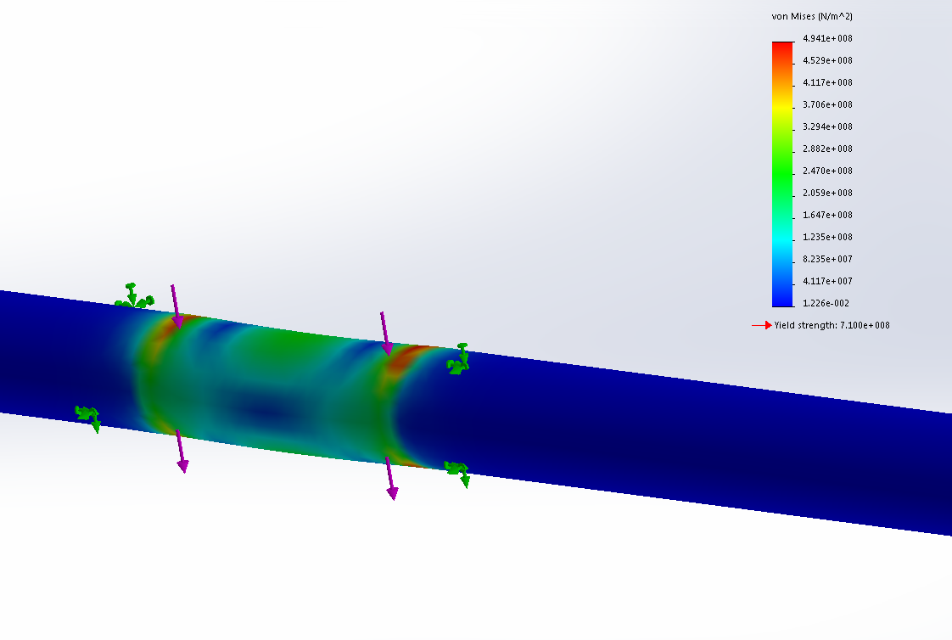

Figure ‑: Von Mises Stress on the Fulcrum Pivot

### The Pin

The pin holds the purpose of holding together the hook and the connecting rod. This part will be undergoing loads of 60 N generated by the hook being pulled downward by the fish. The material chosen for the pin is AISI 4340 normalized steel with yield strength of 710 MPa. Figure (2-34) displays the model design for this part.

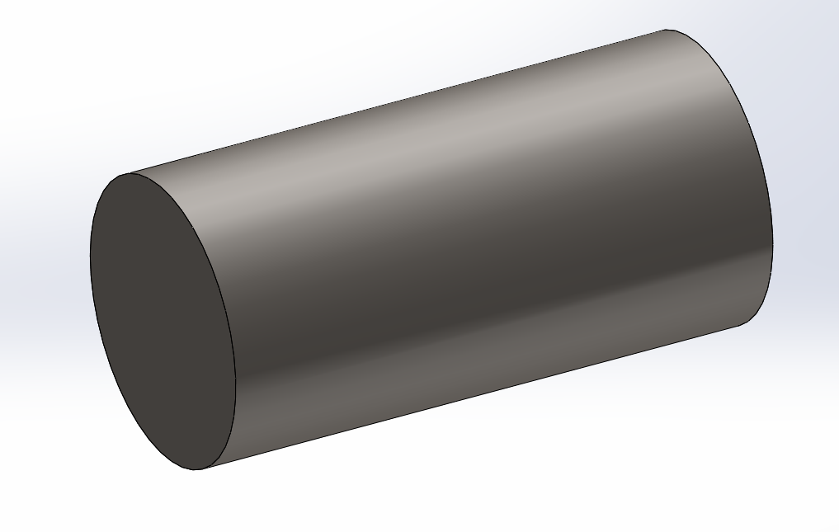

Figure ‑: Pin Design

The displacement analysis gives a max displacement of 2.04 μm on area contact with the hook, increasing in displacement as the load approaches the center of the pin. Analysis is displayed in Figure (2-35).

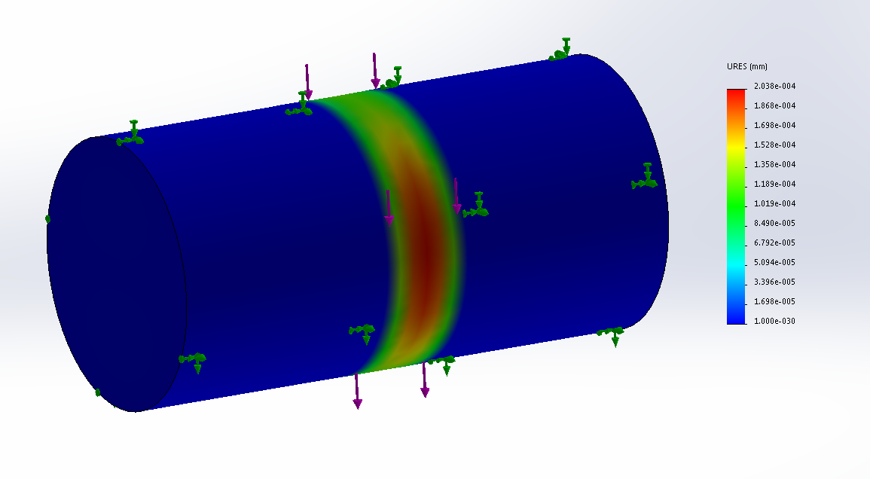

Figure ‑: Finite Element Analysis of Pin Displacement

The Von Mises analysis displays a max stress of 351 MPa supported by the material yield strength of 710 MPa. Contrary to the displacement, the highest stresses are located at the edges of the contact area between the hook and the pin. Figure (2-36) displays the stress analysis.

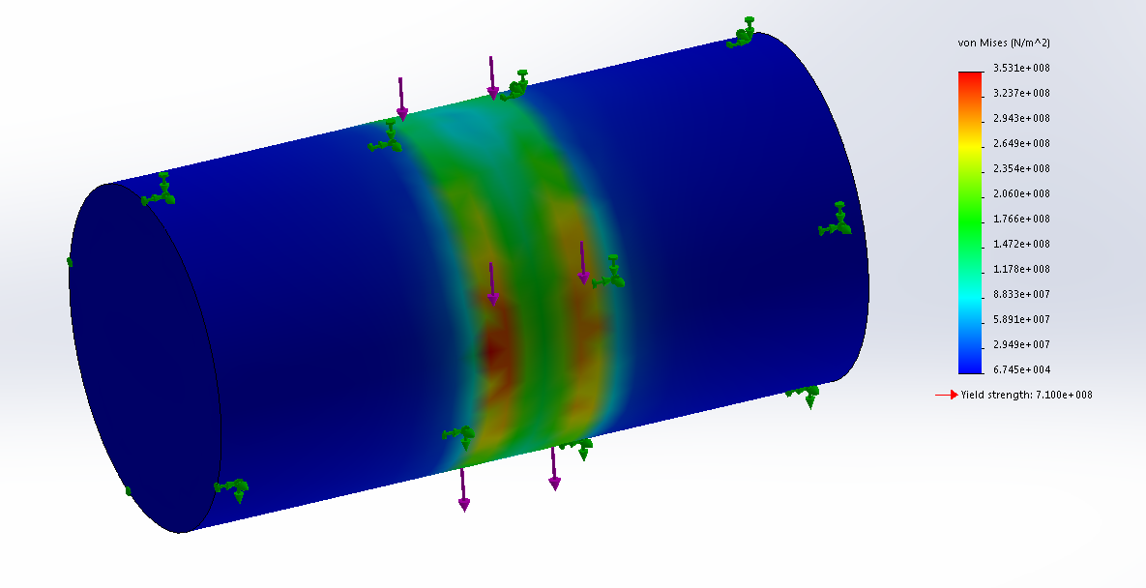

Figure ‑: Finite Element Analysis of Von Mises Stress in the Pin

# Design Solution and Performance

## 3.1 Solution Description

### The Hook

The first part to examine and go through is the hook itself. The hook is what makes direct contact with the fish, and causes the sheath to trigger. The hook is barbless to reduce the damage done to the fish and increase the ease of taking the fish off the hook. Figure 3-1 below shows the model of the hook.



Figure ‑: Hook

As shown in Figure 3-1, the hook has an eye hole at the top for a pin to go through to attach it to the connecting rod. Also, the hook sees a maximum force of 60N, and to make sure the part does not fail, AISI 4340 Steel, Normalized was used. The material property table is shown below in Table 2.

Table : AISI 4340 Steel, Normalized

|  |  |  |
| --- | --- | --- |
| **Property** | **Value** | **Units** |
| Elastic Modulus | 2.05e+011 | N/m2 |
| Poisson's Ratio | 0.32 | N/A |
| Shear Modulus | 8e+010 | N/m2 |
| Mass Density | 7850 | kg/m3 |
| Tensile Strength | 1110000000 | N/m2 |
| Yield Strength | 710000000 | N/m2 |
| Thermal Expansion Coefficient | 1.23e-005 | K-1 |
| Thermal Conductivity | 44.5 | W/(m·K) |
| Specific Heat | 475 | J/(kg·K) |

### The Connecting Rod

The next part to consider is the connecting rod. The connecting rod goes between the hook and the sheath, and is the actual trigger. The connecting rod is one solid piece with two holes cut in the back in order to fit around the hook, and one hole towards the front in order to create a fulcrum point. The connecting rod is shown below in Figure 3-2 and Figure 3-3.

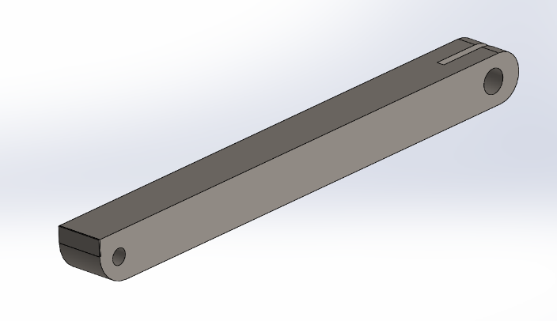

Figure ‑: Connecting Rod Isometric 1

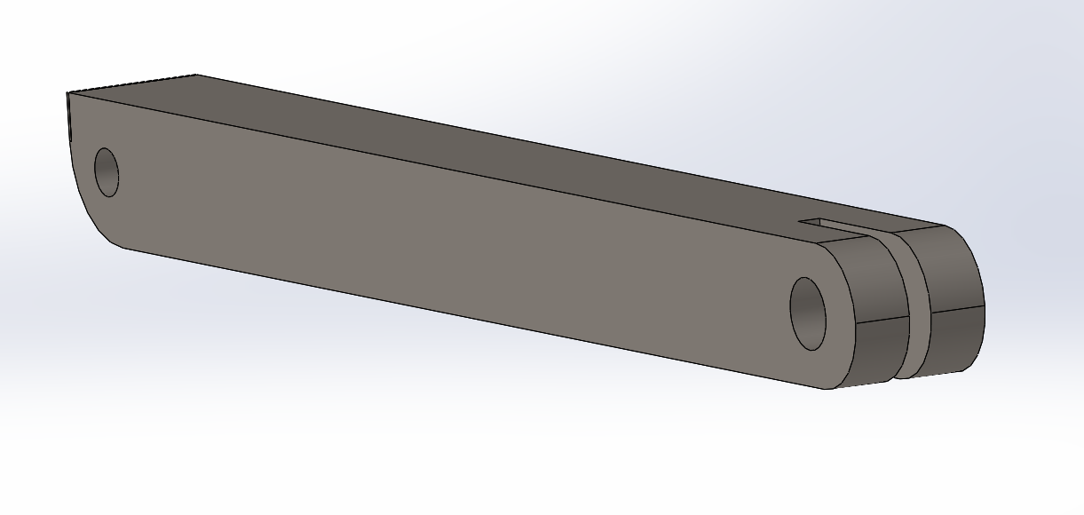

Figure ‑: Connecting Rod Isometric 2

The connecting rod sees two different forces that alternate between positions of the hook and sheath. The maximum load seen is the 60N from the hook while a fish is attached. Due to this, AISI 4340 Steel, Normalized was used again. The property table can be seen above in Table 2.

### The Sheath

The sheath is a very important part in the design. The sheath has a very sharp tip and is pushed by a spring in order to create enough force to pierce through the fishes scales if need be. The idea of the sheath is to cover the hook tip and stay down in order to reduce the chance of the fish releasing itself, without using a barbed hook. The increased force that the sheath is capable of producing also allows the sheath to cut through the scales and cover the hook even if the hook is not protruding from the fish. This greatly increases the success rate and ease of use. Figure 3-4 below shows the sheath.



Figure ‑: Sheath

As shown above in Figure 3-4, the sheath also has an attached knurled thumb slide in order to pull back the sheath and lock it into position to set the trap. Also the inside of the sheath has a stopper for the spring to sit on in order to create the proper forces with the given dimensions. Again, this part uses AISI 4340 Steel, Normalized, and the material property table can be seen above in Table 2.

### The Safety

In order to greatly reduce the chances of somebody accidentally harming themselves while the sheath is set, there is a safety mechanism built in. The safety is a bar that goes between the two body pieces and has a small cutout on the top part of it while in the unsafe position, allowing for the normal operation of the mechanism. When the safety is in the safe position, it sits directly below the connecting rod preventing it from moving down at all and releasing the sheath. There is also a small track on the bottom of the safety and a small bump in the middle of the track on the base in order to give the safety a solid click to know it is in the proper positions, and reduce the chance of it moving on its own. The safety is shown below in Figure 3-5.

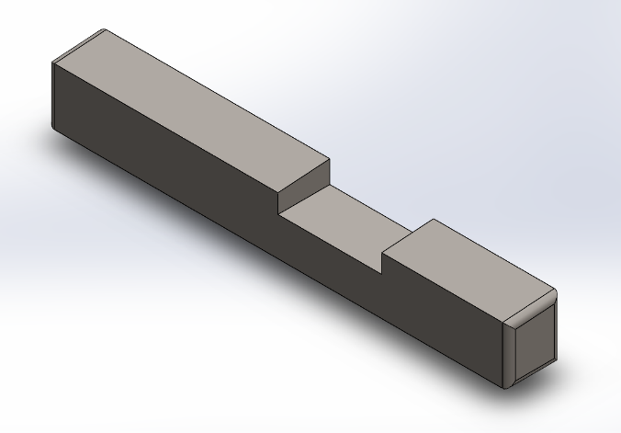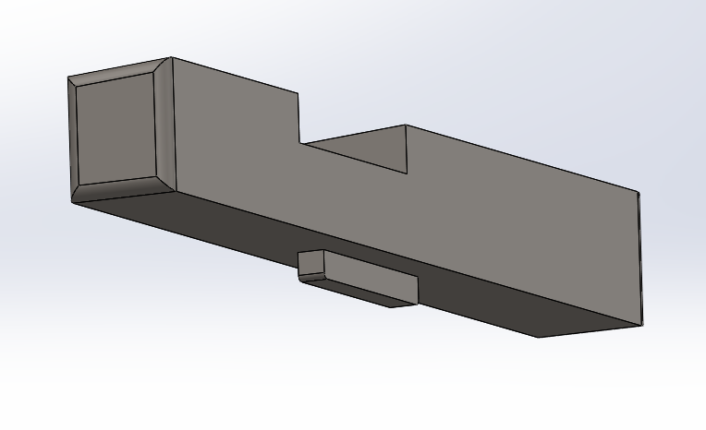

Figure ‑: Safety

In order to reduce the chance of damage to the safety or connecting rod, they are both made of the same material, AISI 4340 Steel, Normalized. And again the material property table can be seen above in Table 2.

### The Housing

The next part to consider is the housing of the unit. The base is one half of the housing for the entire mechanism to fit into. The base consists of all of the cuts and openings for the parts to attach to themselves and has the proper room for any necessary movement, as well as a loop for the fishing line. The housing is split into two pieces in order to increase manufacturability and to facilitate proper assembly. The base of the housing is shown below in Figure 3-6.

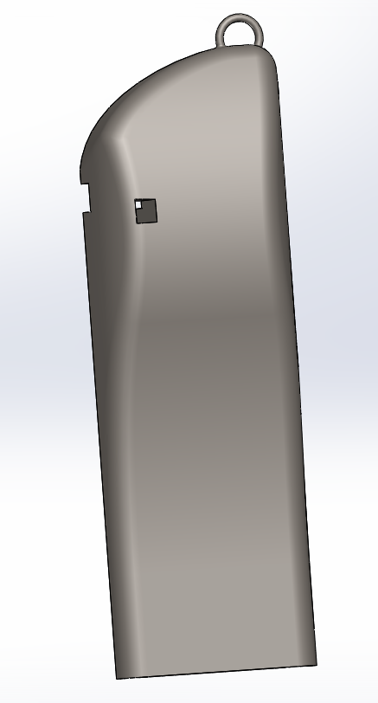

Figure ‑: Base

The other half of the housing is the case. The case has the screw holes that go all the way through in order to be assembled correctly and is essentially just a mirror image of the base. The case is shown below in Figure 3-7.

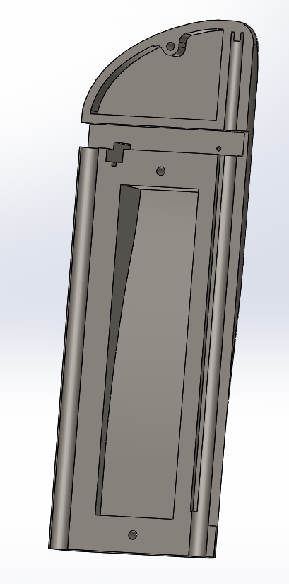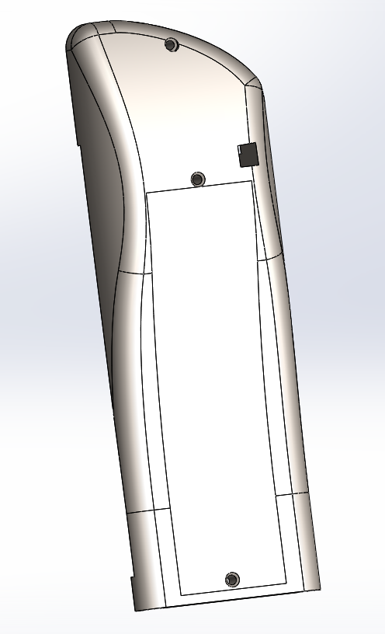

Figure ‑: Case

In order to withstand the proper forces and stresses, AISI 4340 Steel, Normalized was once again used. The material property table can be seen above in Table 2.

### The Assembly

For the whole assembly, start with the base piece, and insert the connecting rod with the fulcrum going through the hole closest to the sheath position into the base. Then insert the hook up through the base to the back of the connecting rod and insert the pin to secure the two pieces together. Next, insert the spring into the sheath and put them both into the base at the proper positions. Then, insert the safety through the cutout and cover the assembled mechanism with the cover piece. Finally, insert the three screws and tighten them to secure the case onto the base, and the mechanism inside. The full exploded view of the assembly is shown below in Figure 3-8.

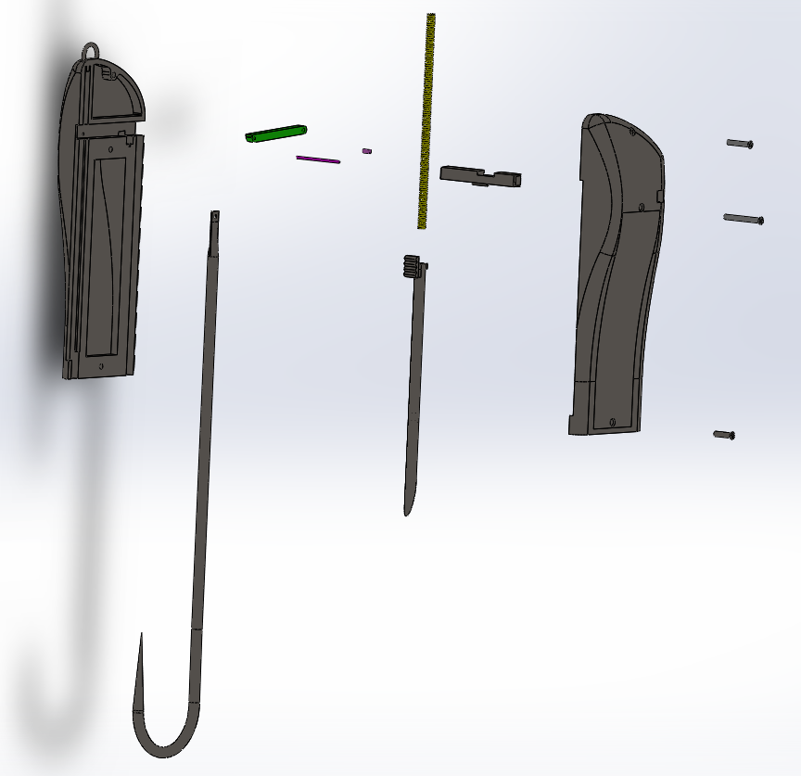

Figure ‑: Exploded Assembly

Also, a close up of the assembled mechanism can be seen below in Figure 3-9.



Figure ‑: Assembled Mechanism

## 3.2 Solution Performance

With the given dimensions and tolerances, everything in the assembly moves unrestricted and without interference. This greatly reduces the amount of wear it would receive, as well as ensuring the longevity of the assembly as a whole. This mechanism and design greatly increases the chances of a successful catch as well as reducing the required skill level needed to catch fish. This enables rookies and pros to enjoy it alike.

This design also allows for the option of scalability. This is to have different size products for different size ranges of fish. The current design displayed in this report discusses the smallest possible design option to ensure that even at such a small scale, the design will work without failure. The main changes in the different sizes of products is the calculations of the spring and the tip of the sheath. These two things require a small amount of calculations done in order to ensure that the required forces remain within the proper limits.

Due to the materials chosen and the design of the assembly, this product is fairly easily manufactured. The design of the split housing, and the simplicity of the parts and mechanism allow for rapid manufacturing and assembling. This greatly reduces the cost needed to create the product and the individual components, allowing for the product to be sold at a very reasonable price. The calculated price for materials and manufacturing of the product is $14.00 per unit, for 1,000 units based on SolidWorks’ calculations. This allows us to charge $19.95 per unit, and profit $5.95 per unit. This manufacturing price will be reduced based on the number of products manufactured, and can create an even larger profit margin, or reduce the price based on sales.

# Discussion

In order to determine if our hook and lure would function properly, research was done in determining the parameters needed for success. Beginning with what fish would be captured, the smallmouth bass was chosen due to the large population of interest among fisherman. Further research was conducted to determine scale composition of the skin as well as the force needed to puncture through the skin by the sheath. These values could be referenced in section 2.2.

Based on the research a value was chosen that would be larger for reliability and conservation. Since the force had been determined spring could be designed with appropriate length and spring constant k. The spring was made of plain carbon steel. The sheath design and size was based on the size of the hook being that the sheath would slide over the tip preventing the fish from leaving. It was found that a 14 gauge hypodermic needle was a perfect size for this application. The hook underwent revisions due to its failure in terms of displacement. This was mitigated by increasing the thickness and overall diameter of the hook.

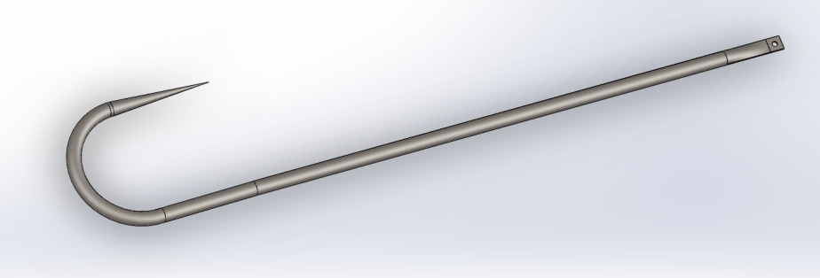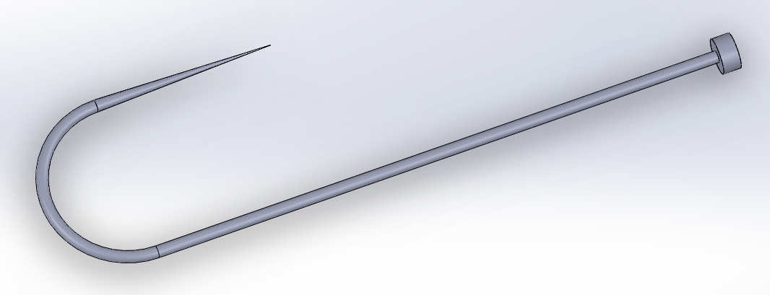

Figure ‑ Optimized Hook (above) Old Hook (below)

Attached to the sheath is a knurled thumb slide protruding from the housing allowing the spring to be placed back into firing position. The sheath and slide are all made of AISI 4340 where the finite element analysis can be referenced in section 2.3. The thumb slide was revised due to its failure from impact. This issue was solved by increasing the width of the union connecting the tab to the sheath.

Research conducted on the weight of the fish allowed for finite element analysis on the hook. AISI 4340 normalized steel was selected due to its high yield strength allowing displacement and deformation of the force on the hook proven reliable. The composition of the connecting rod was chosen to be AISI 4340. Positioning of the pin holes on the rod was based off of the distance between each other and the load applied on the left side. To determine how much vertical force on the hook was necessary to trigger the sheath, moment equations were taken which could be referenced in section 2.2. Since the lure would be casted by the rod in a somewhat circular motion, determination on centripetal forces on the hook would play critical to prevent false activation in the air, also referenced in section 2.2. The connecting rod was originally two separate beams which under loading failed. This was corrected by merging the two beams into one allowing for a wider cross section preventing loading failure.

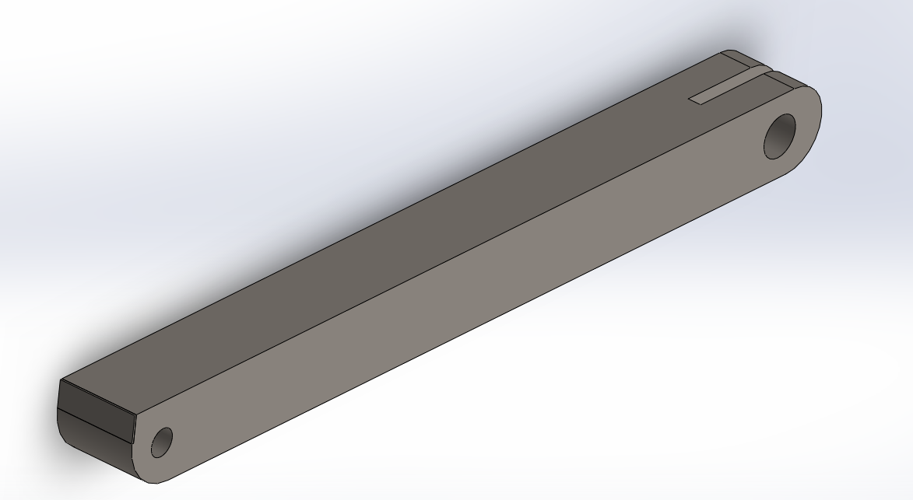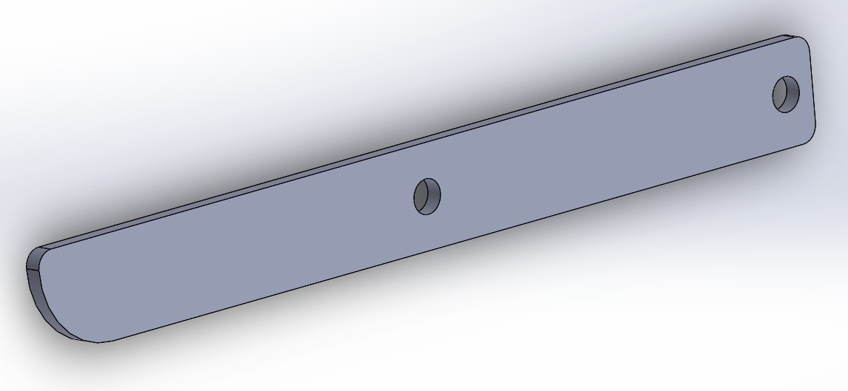

Figure ‑: Optimized Connecting Rod (above) Old Single Sided Connecting Rod (below)

The pins also were made of AISI 4340. This was determined by first finding how the force would be applied over the pins. This metal proved sufficient in terms shearing stress and bending moment which could be referenced in section 2.3. To prevent harm to user while baiting the hook a safety was placed above the hook and below the connecting rod. This would be activated by pushing the safety inwards which would protrude from the housing. The safety was made of AISI 4340.

The body or housing of the mechanical fishing hook underwent the most revision. Made of AISI 4340 the housing was originally a cylinder. For weight reduction and to appeal to fish, the body was thinned out towards the bottom and remained larger at the top where the connecting rod was held. For manufacturing purposes housing was to be cut into two pieces that way the mechanism could be fitted into the housing and then closed through the use of screws. These screws were made of AISI 1020 steel.

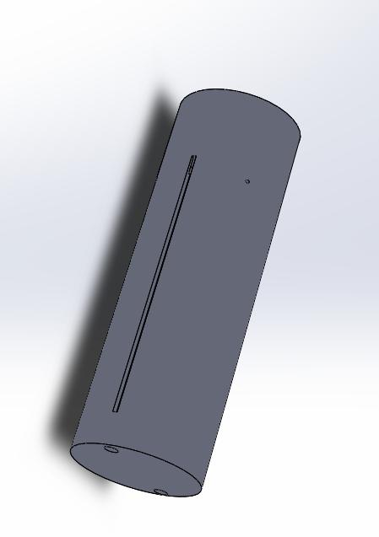

Figure ‑: Original Cylindrical Housing

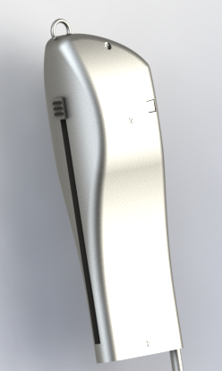

Figure ‑: Optimized Housing

There were multiple designs that had been rejected for various reasons. Most of the designs were too bulky for example the style in figures (4-1) and (4-3). Another issue with the design for Figure (4-1) was the added hooks would not have increased the success rate of capturing the fish but rather gets in the way when considering stealth and practical use. Figure (4-2) illustrates how the final design came to be, except that the housing was too rectangular and slim calling for a redesign of the mechanism. Figures (4-5) through (4-7) illustrate other non-selected designs.

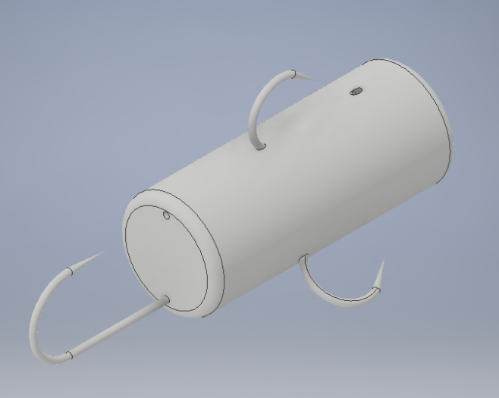

Figure ‑: Disqualified Option

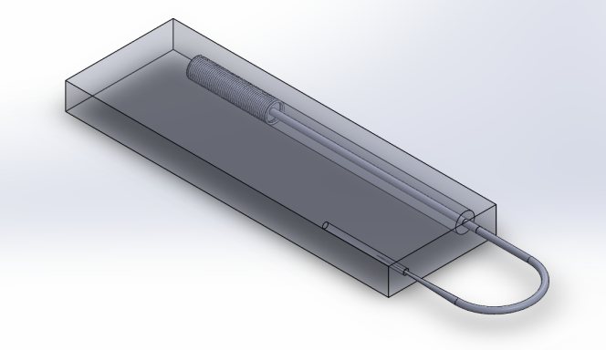

Figure ‑: Disqualified Option

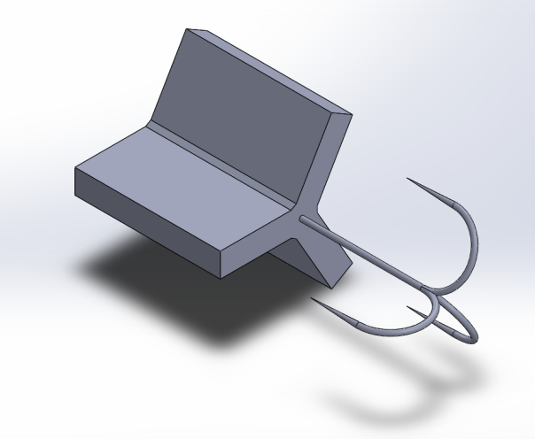

Figure ‑: Disqualified Option

# Conclusion

In conclusion, the hook successfully meets all required specifications as well as satisfying failure criteria and analysis. A spring was successfully synthesized based on the given dimensions and requirements to puncture through fish scale and skin. Kinematic and dynamic analyses were successfully conducted and proven with SolidWorks Finite Element Analysis simulations. Individual parts were analyzed and put through stress and displacement analysis. The Finite Element Analysis results lead to appropriate material selection for each part to ensure stability and longevity of the product. This allowed for the optimization of the mechanism and the parts themselves. Manufacturability was incorporated into the design and reduction of excess materials was conducted. A design down select was performed to select the most optimal and cost effective design solution to solve the proposed objectives.

# References

[1-1] Price M. World’s Oldest Fishhook Found on Okinawa. Science Magazine, Web. (Accessed on January 28, 2017).

[1-2]Van Vleck G. Fish Hook. US842594A (1908)

[1-3] Gafford R. Spring-Loaded Fish Hook. US20140283433A1 (2014)

[1-4] Lane N. Spring Augmented Fish Hook. US7353633B1 (2005)

[2-1] American Expedition. Smallmouth Bass Information. Web. (Accessed on March 4 2017)

[2-2] Stein D. Choosing Line for Small Mouth Bass Fishing. Web. (Accessed on February 26 2017)

[2-3] Ottolini S. Halpin G. and LaBruzzo P. Tensile Strength of Fishing Line. Engineering 45. Santa Rosa, CA. December 2009.

[2-4] Zhu D. Szewciw L. Barthelat F. and Bernerey F. Puncture of the Scaled Skin from Striped Bass. Journal of the Mechanical Behavior of Biomedical Materials. 2013.

[2-5] Zhu D. Fuentes C. Mota M. Szewciw L. Bernerey F. and Barthelat F. Structure and Mechanical Performance of a Mechanical Fish Scale. Journal of Advanced Biomaterials. 2011.

[2-6] Swanson B. Matev I. and Groot G. The Strength of the Hand. Bulletin of Prosthetics Research. 1970.

[2-7] Sclater N. Mechanisms and Mechanical Devices Sourcebook McGraw Hill Professional, Durham NC. 2011.

[2-8] Groover M. Fundamentals of Modern Manufacturing. Wiley 6th Ed. Hoboken NJ. 2015.

[2-9] Bryant N. Outdoors; In Pursuit of the Longest Cast. New York Times 1987.

[2-10] Klawe W. and Dickie L. Biology of the Bloodworm. Fisheries Research Board. Ottawa Canada. 1957.

# Appendix

## A.1 Nomenclature

$$A=Surface area of needle tip, m^{2}$$

$$a= acceleration, \frac{m}{s^{2}}$$

$$b= base dimension$$

$$D=diameter of coil, m$$

$$d=diameter of wire, m$$

$$F=Force, N$$

$$G=shear modulus of elasticity, Pa$$

$$h=height dimension, m$$

$$I= Inertia, m^{4}$$

$$k=spring constant,\frac{N}{m}$$

$$M=moment, Nm$$

$$N=number of turns of the coil$$

$$ω= Angular velocity,\frac{rad}{s}$$

$$P=Pressure, Pa$$

$$π=3.14, constant$$ $$r=raidus, m$$

$$σ_{B}= Bending stress$$

$$t= time$$

$$V_{0}= Release velocity,\frac{m}{s} \\ V_{f}= final velocity,\frac{m}{s}$$

$$τ= Shearing force \\ θ= Angle of cast throw, rad$$

$$V = shear force, N \\ x=distance, m$$

$∆y= height along y-axis, m$

## A.2 Project Schedule

Mechanically Activated Fishing Hook Work Breakdown Schedule



|  |  |
| --- | --- |
| **Task 1- Proposal**   * Prepare Proposal * Submit Proposal   **MS.1** Proposal Approved  **Task 2- Concept Development**   * Existing product research * Trade Study * Concept Development * Concept Down-Select   **MS.2** Concept Developed  **Task 3- Kinematic/Dynamic Analysis**   * Prepare Kinematic Model * Prepare Dynamic Model * Refine Kinematic Model * Refine Dynamic Model   **MS.3** Project Analysis Complete | **Task 4- 3D: CAD Model**   * Prepare 3D CAD model * Material selection * CAE stress analysis * CAE displacement analysis   **MS.3** Project Analysis Complete  **Task 5- Concept Refinement**   * Weight reduction * Fatigue analysis * Subcomponent interactions   **MS.4** Project Complete  T**ask 6- Final Project Report/Presentation**   * Prepare Final Project Report * Prepare Final Presentation * Deliver Final Presentation   **MS.4** Project Complete |

## A.3 Preceding Patent Claims Lists

### US 842594 A - Fish-Hook

The independent claims of patent US 842594 A are: **[1-2]**

1. A fish-hook provided with a long, narrow and gradually-tapered point, one side of which terminates in a forked barb, having a notch (8) which spaces the barbs from the bill.

2. A fish-hook having a point terminating in a forked barb on the outer side of the bill, the barbs being spaced from the bill by a common notch provided in the bill at the base of the point.

3. A fish-hook having a point triangular in cross-section, said point having one flat side which terminates in a forked barb.

### US20140283433 A1 - Spring-Loaded Fish Hook

The independent claims of patent US20140283433 A1 are: **[1-3]**

1. A first hook connected to a first shaft and a second hook connected to a second shaft

2. Wherein said first shaft and said second shaft are connected to a resistance element

3. Wherein said resistance element biases said first and second shaft apart from one another

4. A catch element disposed on said first shaft

5. A slide element disposed on said second shaft and adapted to slide thereon

6. Wherein engagement of said slide element with said catch element functions to hold said first and second shafts under tension in a closed configuration

7. A releasing line adapted to engage with said slide element

8. Wherein said releasing line is adapted to disengage said slide element from said catch element when said releasing line is pulled, allowing said first and second shafts to move apart from one another so as to result in an open configuration.

### US 7353633 B1 - Spring Augmented Fishhook

The independent claims of patent US 7353633 B1 are: **[1-4]**

A. A spring augmented fish hook comprising of:

1. A hook having first and second ends with a hook member on its second end

2. A clip to which a fishing line attaches

3. A resilient spring connected between the clip and the hook member first end, such that when the hook is pulled downward such as by a fish, the spring deforms within its elasticity between the clip and the hook allowing limited movement of the hook against spring bias and moderating impact of the fish on the hook

4. Wherein the resilient spring comprises a coil spring with winds between first and second ends and defining a channel through its center between first and second ends

5. Wherein a portion of the clip passes through the spring channel

6. Wherein the clip comprises a spring block at its first end preventing the spring from passing off the clip, and

7. Wherein the clip comprises a bend at a point of flexure intermediate the clip that divides the clip into first and second legs with latch members that match to latch the legs together at a latch point a distance from the point of flexure, the spring retained between the point of flexure and the latch point.

B. A spring augmented fish hook comprising of:

1. A hook having first and second ends with a hook member on its second end, wherein the hook comprises a first spring block at its first end preventing the spring from passing off the hook first end

2. A clip to which a fishing line attaches

3. A resilient spring connected between the clip and the hook member first end, such that when the hook is pulled downward such as by a fish, the spring deforms within its elasticity between the clip and the hook allowing limited movement of the hook against spring bias and moderating impact of the fish on the hook

4. Wherein the resilient spring comprises a coil spring with winds between first and second ends and defining a channel through its center between first and second ends

5. Wherein a portion of the clip passes through the spring channel

6. Wherein the clip comprises a second spring block at its first end preventing the spring from passing off the clip, and

7. Wherein the clip and a shank of the hook pass through the spring channel from opposite spring ends with the spring between first and second spring blocks, and

8. Wherein the clip comprises a bend at a point of flexure intermediate the clip that divides the clip into first and second legs with latch members that match to latch the legs together at a latch point a distance from the point of flexure, the spring retained between the point of flexure and the latch point, said shank of the hook passing through the spring channel slidably side by side with said clip portion passing through the spring channel.

C. A spring augmented fish hook comprising of:

1. A hook member further comprising an eye on a first end of an elongate leg portion and a hook on a second end of the leg portion

2. A coil spring having a diameter smaller than the eye and forming a spring channel longitudinal through its center through which the elongate leg portion passes

3. A clip resiliently bending at a point of flexure into elongate first and second clip members with proximal ends at the point of flexure and with distal ends away from the point of flexure, the first clip member passing downward through the eye and then through the channel and extending beyond spring upper and lower ends with a first latch member on its distal end, and the second clip member extending generally downward with a second latch member on its distal end matching the first latch member such that the first and second latch members latch together as the first and second clip members are urged together under flexure, the spring held on the hook member leg portion between the eye and the latched first and second clip members as spring stops such that when the hook is pulled downward such as by a fish with the clip stationary relative to the hook member, the spring compresses between the eye and the latched clip members allowing limited movement of the hook against spring bias when initially pulled.